EdStats Introductory Mock Final Save As “Your_Name_Final.doc”

Data Set: “CILS is a longitudinal study designed to study the adaptation process of the immigrant second generation which is defined broadly as U.S.-born children with at least one foreign-born parent or children born abroad but brought at an early age to the United States. The original survey was conducted with large samples of second-generation children attending the 8th and 9th grades in public and private schools in the metropolitan areas of Miami/Ft. Lauderdale in Florida and San Diego, California” (from the website description of the data set).

Theory: There is a positive feedback loop between success in school and high career aspirations. Success in school feeds into high career aspirations. High career aspirations feed into success at school. This feedback loop affects children of immigrants.
Research Question 1: In the population of 8th/9th grade children of immigrants from Miami/Ft. Lauderdale and San Diego, are students’ GPAs positively correlated with the SEIs of their desired jobs?
Outcome: GPA, grade point average
Predictors:
- DesiredJobSEI, the SEI associated with the student’s desired adult employment. Duncan's (1961) Socioeconomic Index (SEI) is a composite of occupational prestige, income, and education. The higher the score on this measure, the more prestige, income and education are associated with the student’s desired occupation.
- Female, a dichotomy where Female = 1 and Male = 0.
- GradesImportant, a polychotomy that records the student’s response to a survey prompt, “Good grades are important to me.” 1 = Very True, 2 = Partly True, 3 = Not Very True, 4 = Not True At All The corresponding dummies are GradesVeryImportant, GradesPartlyImportant, GradesNotVeryImportant and GradeNotImportant.

Post Hole 2—Use exploratory data analytic techniques to describe the distribution of a variable.

Explore GPA: (A checklist is good.)
*
Explore DesiredJobSEI: (A checklist is good.)
*
Explore Female: (A checklist is good.)
*
Explore GradesImportant: (A checklist is good.)
*

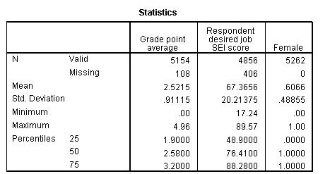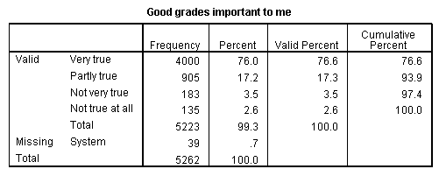
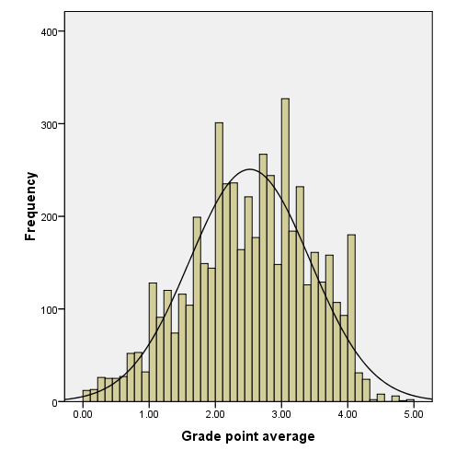 | 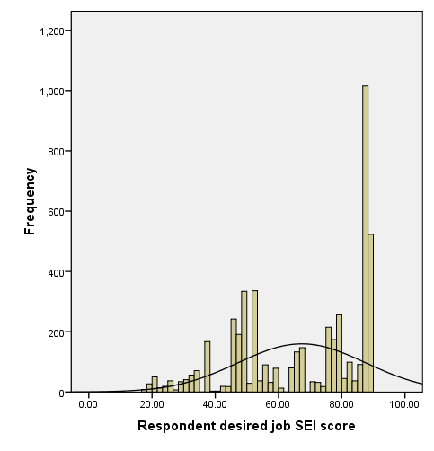
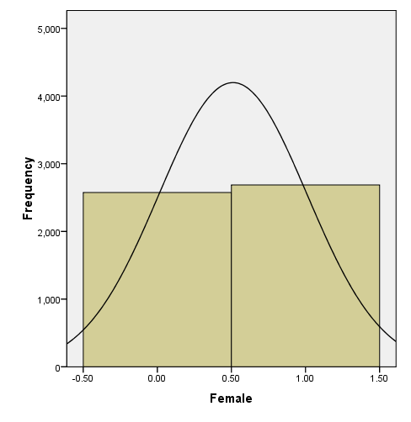 | 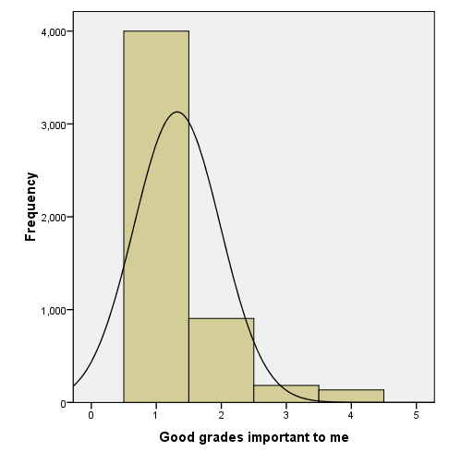

Post Hole 1—Use exploratory data analytic techniques to investigate the relationship between two variables.
Post Hole 4—Interpret a correlation matrix.

Explore GPA vs. DesiredJobSEI: (A checklist is generally good, but interpret the magnitude with a careful sentence.)
*
Explore GPA vs. Female: (A checklist is generally good, but interpret the magnitude with a careful sentence.)
*
Interpret the correlation matrix :
*
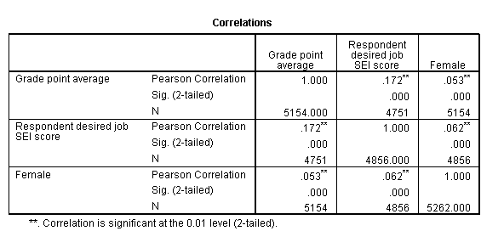

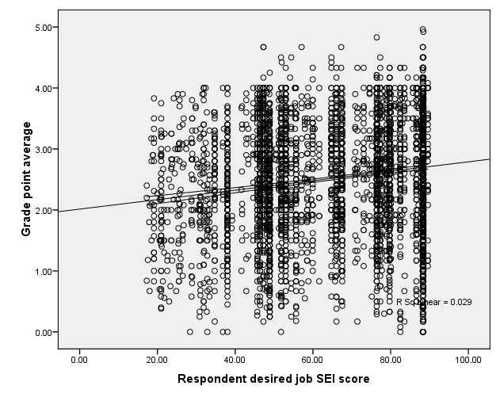
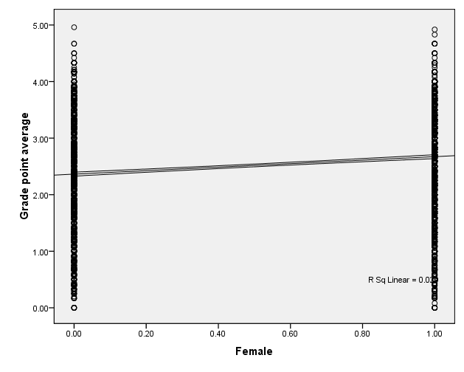

Here is the relationship between the two predictors. You do not need to conduct exploratory data analysis on this relationship, but you do want to check it before you interpret the Pearson correlation. | 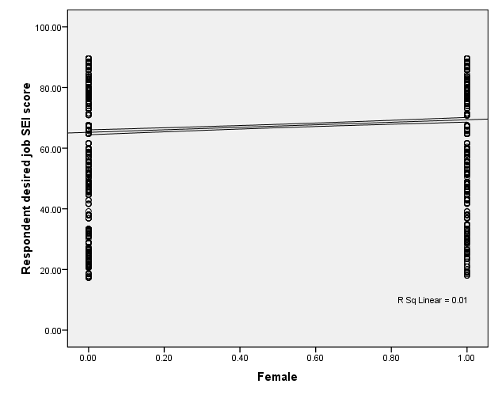

Post Hole 5—Interpret an R² statistic verbally and, using Boolean circles, graphically.
Post Hole 6—State the null hypothesis of a test for statistical significance; reject (or not) the null hypothesis; draw an inference (or not) from a sample to a population.
Post Hole 7—Interpret a confidence interval from a frequentist perspective and from a Bayesian perspective.
Post Hole 8—Evaluate the assumptions underlying a simple linear regression.
Interpret the R² statistic: (One careful sentence is good.)
Outcome
Predictor
*
Test for statistical significance:
*
Interpret the confidence interval: (Use both perspectives.)
*
Evaluate the assumptions: (A checklist is good.)
*

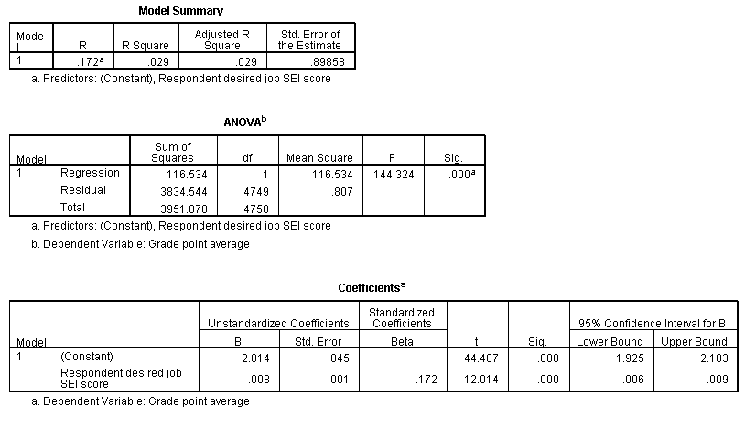
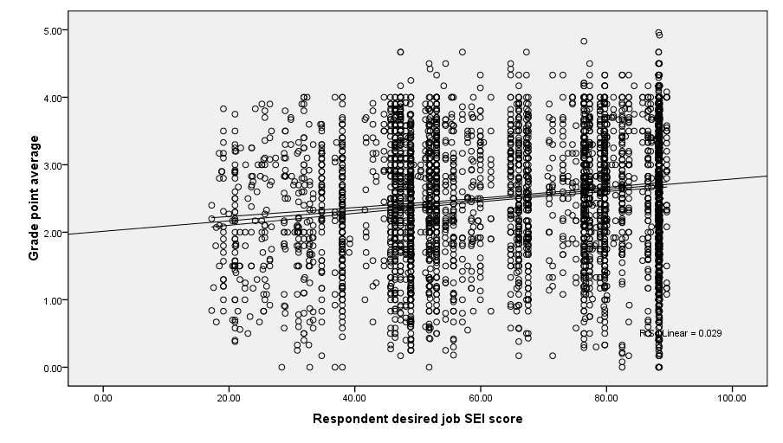

Post Hole 5—Interpret an R² statistic verbally and, using Boolean circles, graphically.
Post Hole 6—State the null hypothesis of a test for statistical significance; reject (or not) the null hypothesis; draw an inference (or not) from a sample to a population.
Post Hole 7—Interpret a confidence interval from a frequentist perspective and from a Bayesian perspective.
Post Hole 8—Evaluate the assumptions underlying a simple linear regression.
Interpret the R² statistic: (One careful sentence is good.)
Outcome
Predictor
*
Test for statistical significance: (Use the APA style.)
Yakkity yak yak yak, t(df) = xx.x, p = .xxx.
*
Interpret the confidence interval: (Use both perspectives.)
*
Evaluate the assumptions: (A checklist is good.)
*
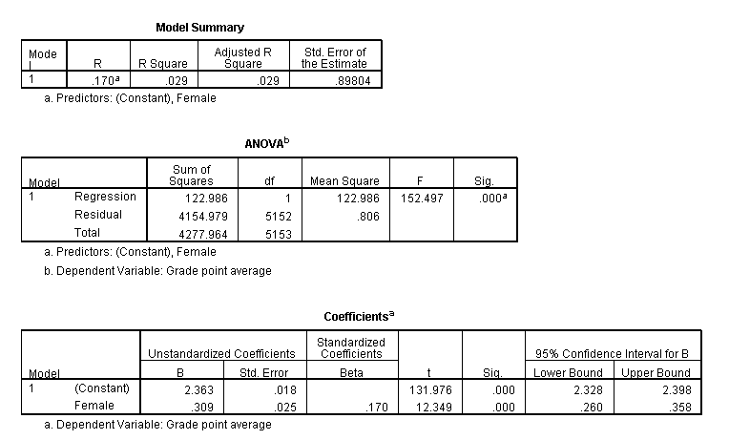
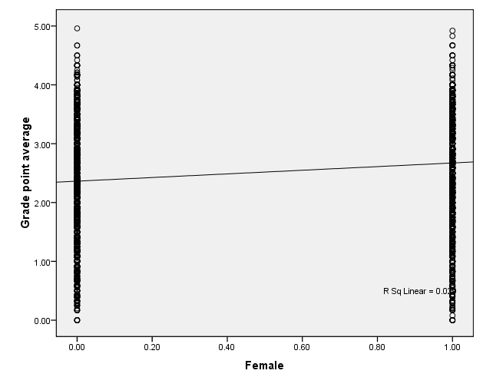

Post Hole 9—Interpret the parameter estimates and F-test from regressing a continuous variable on a set of dummy variables.

Interpret the parameter estimates and F-test: (Use the APA style.)
Yakkity yak yak yak, F(df_{between}, df_{within}) = xx.x, p = .xxx, η² =.xxx.
*
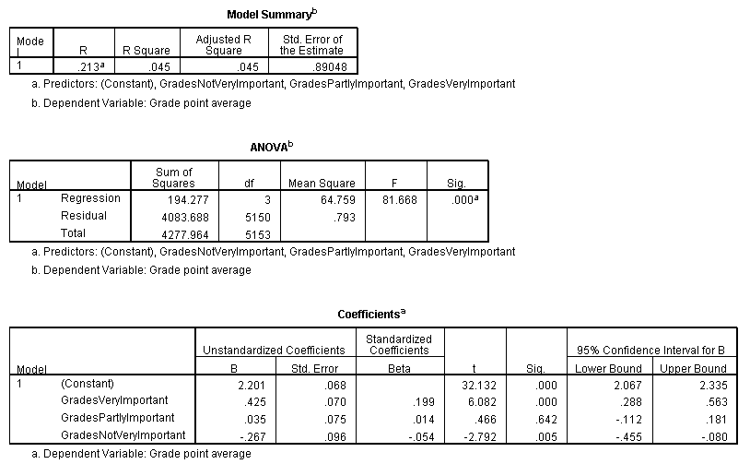
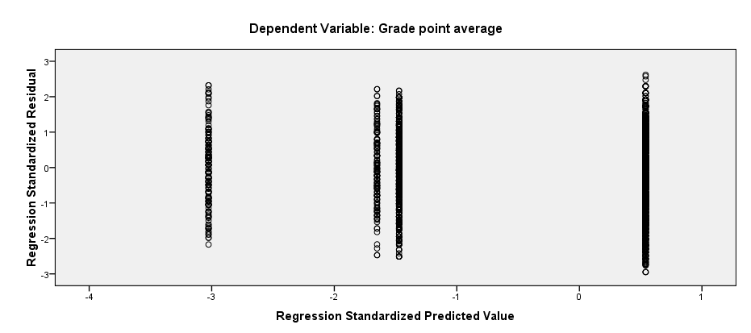

Post Hole 10—Interpret a two-way analysis of variance using F-tests and graphs.

Interpret the two-way ANOVA: (Fully interpret at least one F-test,
using the APA style. Mention the F-tests that you do not fully interpret.)
Yakkity yak yak yak, F(df_{between}, df_{within}) = xx.x, p = .xxx, partial η² =.xxx.
*
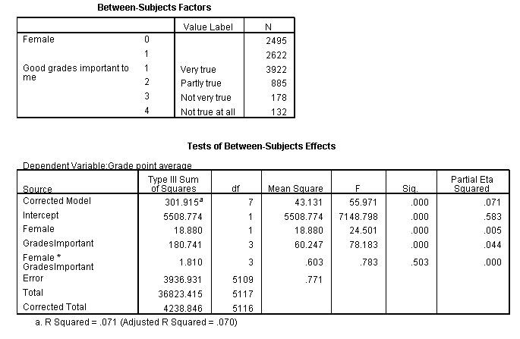
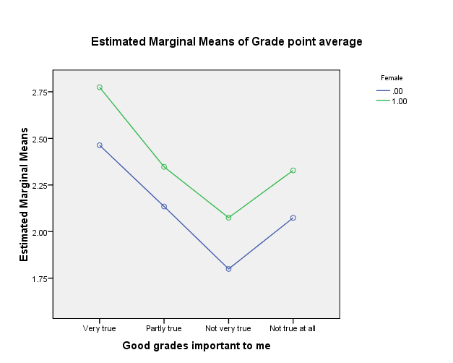

Post Hole A—Interpret a contingency table with chi-square statistic.

Interpret the contingency table: (Use the APA style.)
Yakkity yak yak yak, χ²(df) = xx.x, p = .xxx.
*
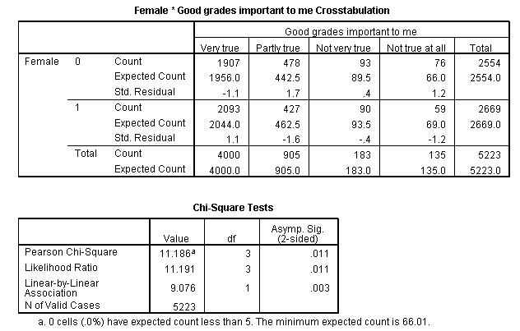

Post Hole 3—Conduct a z-score transformation by hand from a small data set.

High School Student GPAs: 4 0 4 3 3 4 2 2 4 4

Please show your work:
*
Please note the mean of the raw distribution:
Please note the sum of squared mean deviations:
Please note the variance of the raw distribution:
Please note the standard deviation of the raw distribution:

