EdStats.Org Child Life Postholes Answers

Data Set: These data are from a child life research study (N = 74).

Theory: Child life specialists respond to the psychological needs of the whole child (cognitive, emotional and social), and because of this holistic responsiveness, child life services effectively reduce anxiety.

Research Questions: In the final five minutes of the pre-induction wait, are the intervention patients less anxious on average than the control patients?

Outcome 1: MYPAS, continuous, evaluation on the modified Yale Perioperative Anxiety Scale, with possible scores of 23 (not apparently anxious) to 100 (extremely anxious).

Outcome 2: Anxious, dichotomous, , an indicator variable taking values of 1 if the patient rated a 30 or greater on the modified Yale Perioperative Anxiety Scale and 0 if not.

Question Predictor: Intervention, dichotomous, an indicator variable taking values of 1 if the patient was randomly assigned to the child life intervention group and 0 if the patient was randomly assigned to the control group.

Post Hole 2—Use exploratory data analytic techniques to describe the distribution of a variable.

Explore MYPAS: (A checklist is good.)
Shape: Positively skewed. (FYI: major floor effect! This is a censored variable.)
Location: Median = 25
Spread (R): Ranges from 23 to 83, with a midpsread of 38-23 = 15. Whiskers are 15*1.5 = 23. RUB = 38+ 23 = 61. According to the RUB there are bunch of upper outliers. RLB = 23 – 23 = 0. No lower outliers.
Spread (SPSS): Ranges from 23 to 83, with a midpsread of 40-23 = 17. Whiskers are 17*1.5 = 26. RUB = 40+ 26 = 66. According to the RUB there are bunch of upper outliers. RLB = 23 – 26 = -3. No lower outliers.
*
Explore Intervention: (A checklist is good.)
54% of the patients received the intervention.
*

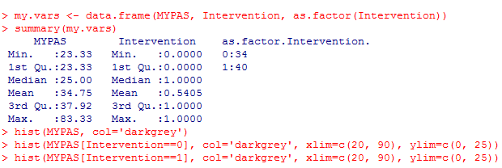
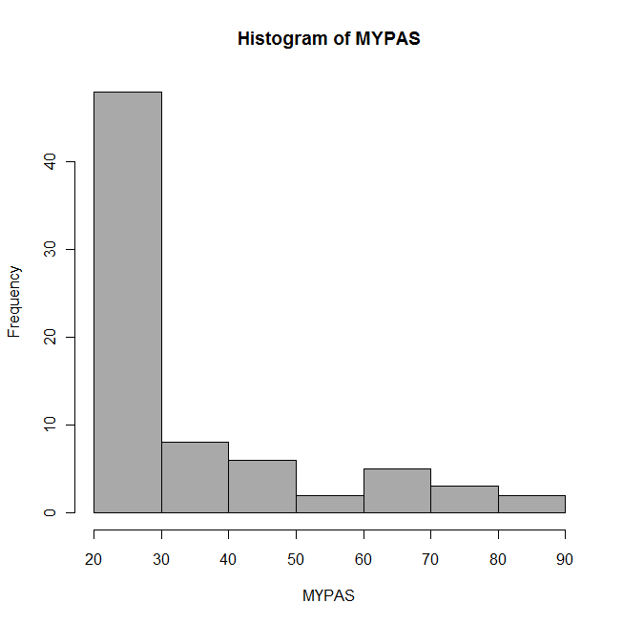 | 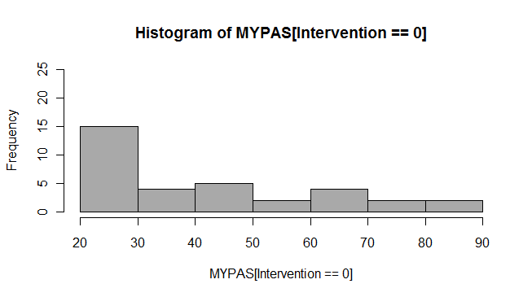
 | 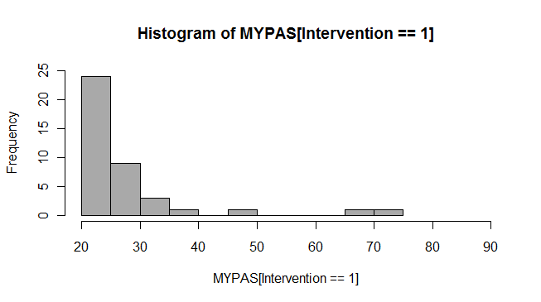

Post Hole 1—Use exploratory data analytic techniques to investigate the relationship between two variables.
Post Hole 4—Interpret a correlation matrix.

Explore MYPAS vs. Intervention: (A checklist is generally good, but interpret the magnitude with a careful sentence.)
Direction: Negative.
Outliers: This is tricky. The distributions are so skewed that you can construe all the very anxious patients as outliers, but especially in the intervention group.
Linearity: Necessarily.
Magnitude: On average, in our sample, intervention patients rate 14 points lower on the MYPAS. They are less anxious on average.
And
Strength: This relationship is strong enough to convince me that, if my two-year old goddaughter needed surgery, I would wish to have a child life specialist work with her. Sure, there is some spread around the predictions (especially for the control group), but I can clearly see the relationship through the spread.
*
Interpret the correlation matrix :
The correlation (no matrix here, just one correlation) tells us that intervention patients are, on average, less anxious than control patients. (Moderate correlation?)
*

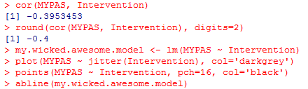

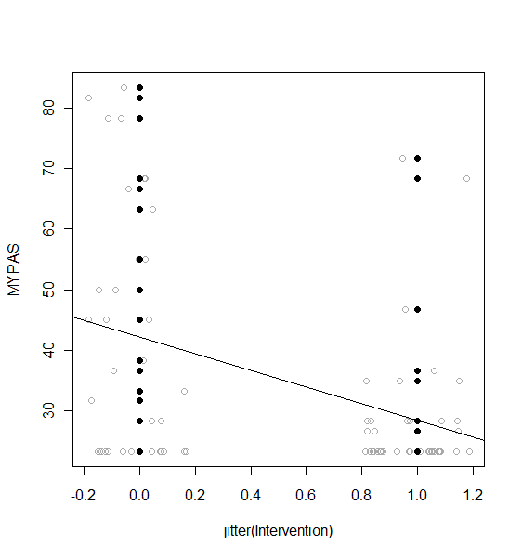

Post Hole 5—Interpret an R² statistic verbally and, using Boolean circles, graphically.
Post Hole 6—State the null hypothesis of a test for statistical significance; reject (or not) the null hypothesis; draw an inference (or not) from a sample to a population.
Post Hole 7—Interpret a confidence interval from a frequentist perspective and from a Bayesian perspective.
Post Hole 8—Evaluate the assumptions underlying a simple linear regression.
Interpret the R² statistic: (One careful sentence is good.)
Intervention predicts about 16% of the variation in MYPAS ratings.  MYPAS | Intervention
*
Test for statistical significance: (Use the APA style.)
The intervention had a statistically significant anxiolytic effect, t(72) = 3.65, p < .001.
The null hypothesis is that there is not relationship in the population between MYPAS ratings and intervention/control status. If the null where true, we would see a relationship as strong (or stronger) than ours less than 5% ( actually less than .05%) of the time, so we reject the null, and conclude that there is a relationship (an anxiety reducing effect) in the population from which we randomly drew our sample.
*
Interpret the confidence interval: (Use both perspectives.)
Freq: The observed difference of 14 points on the MYPAS includes sampling error. We can use confidence intervals to give us a range of plausible values for the true difference in the population. That range is 6 to 23 points. In our lifetime, we expect such ranges to fail 5% of the time, but we’ll hope that ours is one of the lucky 95%.

Bayes: In the absence of further information, we are 95% confident that the intervention reduces MYPAS ratings, on average, somewhere between 6 and 23 points.
*
Evaluate the assumptions: (A checklist is good.)
Homoskedasticity: Maybe problematic. The control group has more variation.
Independence: These patients have no contact with each other. I’m not worried here.
Normality: This is the biggie. But the problem goes beyond normality (within groups). The problem is really about censoring, the floor effect. Our MYPAS instrument is not sensitive to differences in anxiety at the lower end of the anxiety spectrum. Consequently, a whole bunch of kids get stuck at 23. Some would spread out lower if they could, making the intervention effect even greater! Our estimate is biased too small.
Linearity: No problem.
Outliers: Maybe in the treatment group, upper outliers.
*
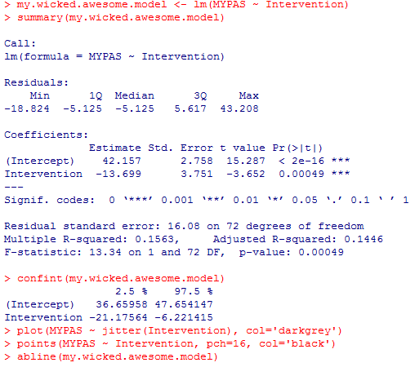

Post Hole A—Interpret a contingency table with chi-square statistic.

Interpret the contingency table: (Use the APA style.)
The intervention had a statistically significant anxiolytic effect, χ² (1) = 11.9, p < .001.

(I’m going to focus on the -1.9 residual, because it tells my story better.) If the differences in anxiety we see in the treatment and control groups were due to randomness, we would expect 14 anxious intervention patients, but we only observe 7.

(In fact, I would really use percentages. I would say 56% of control patients were clinically anxious, but only 18% of intervention patients were clinically anxious. This tells the story better than over/under representation, I think.)

Assumptions-
Independence: Okay.
Expected Cell Count: Okay. Greater than 5 in all four cells.
*

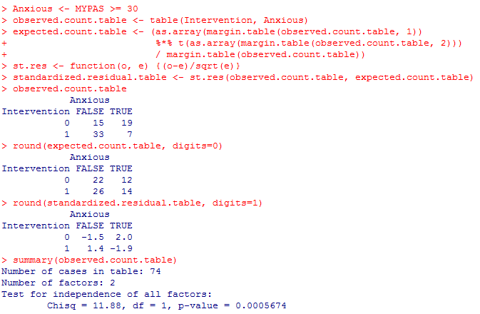

Post Hole 3—Conduct a z-score transformation by hand from a small data set.

MYPAS: 23 23 23 23 23 23 33 83
Please show your work:
Raw Score | Mean | Mean Deviation | Squared Mean Deviation | Z Score
23 | 31.75 | -8.75 | 76.5625 | -0.41663
23 | 31.75 | -8.75 | 76.5625 | -0.41663
23 | 31.75 | -8.75 | 76.5625 | -0.41663
23 | 31.75 | -8.75 | 76.5625 | -0.41663
23 | 31.75 | -8.75 | 76.5625 | -0.41663
23 | 31.75 | -8.75 | 76.5625 | -0.41663
33 | 31.75 | 1.25 | 1.5625 | 0.059519
83 | 31.75 | 51.25 | 2626.563 | 2.440279

*
Please note the mean of the raw distribution: | 31.75
Please note the sum of squared mean deviations: | 3087.5
Please note the variance of the raw distribution: | 441
Please note the standard deviation of the raw distribution: | 21

MYPAS: 23 23 23 23 23 23 83 83
Please show your work:
Raw Score | Mean | Mean Deviation | Squared Mean Deviation | Z Score
23 | 38 | -15 | 225 | -0.54006
23 | 38 | -15 | 225 | -0.54006
23 | 38 | -15 | 225 | -0.54006
23 | 38 | -15 | 225 | -0.54006
23 | 38 | -15 | 225 | -0.54006
23 | 38 | -15 | 225 | -0.54006
83 | 38 | 45 | 2025 | 1.620185
83 | 38 | 45 | 2025 | 1.620185

*
Please note the mean of the raw distribution: | 38
Please note the sum of squared mean deviations: | 5400
Please note the variance of the raw distribution: | 771.4
Please note the standard deviation of the raw distribution: | 27.8

Anxious: 0 0 0 0 0 0 1 1
Please show your work:
Raw Score | Mean | Mean Deviation | Squared Mean Deviation | Z Score
0 | 0.25 | -0.25 | 0.0625 | -0.54006
0 | 0.25 | -0.25 | 0.0625 | -0.54006
0 | 0.25 | -0.25 | 0.0625 | -0.54006
0 | 0.25 | -0.25 | 0.0625 | -0.54006
0 | 0.25 | -0.25 | 0.0625 | -0.54006
0 | 0.25 | -0.25 | 0.0625 | -0.54006
1 | 0.25 | 0.75 | 0.5625 | 1.620185
1 | 0.25 | 0.75 | 0.5625 | 1.620185

*
Please note the mean of the raw distribution: | .25
Please note the sum of squared mean deviations: | 1.5
Please note the variance of the raw distribution: | .214
Please note the standard deviation of the raw distribution: | .463

