EdStats.Org Child Life Postholes Save As “Your_Name_Child_Life.doc”

Data Set: These data are from a child life research study (N = 74).

Theory: Child life specialists respond to the psychological needs of the whole child (cognitive, emotional and social), and because of this holistic responsiveness, child life services effectively reduce anxiety.

Research Questions: In the final five minutes of the pre-induction wait, are the intervention patients less anxious on average than the control patients?

Outcome 1: MYPAS, continuous, evaluation on the modified Yale Perioperative Anxiety Scale, with possible scores of 23 (not apparently anxious) to 100 (extremely anxious).

Outcome 2: Anxious, dichotomous, , an indicator variable taking values of 1 if the patient rated a 30 or greater on the modified Yale Perioperative Anxiety Scale and 0 if not.

Question Predictor: Intervention, dichotomous, an indicator variable taking values of 1 if the patient was randomly assigned to the child life intervention group and 0 if the patient was randomly assigned to the control group.

Post Hole 2—Use exploratory data analytic techniques to describe the distribution of a variable.

Explore MYPAS: (A checklist is good.)
*
Explore Intervention: (A checklist is good.)
*

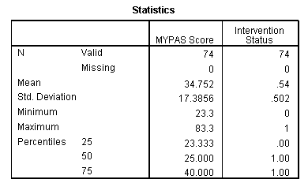
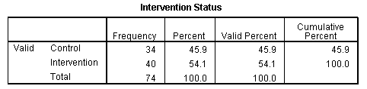
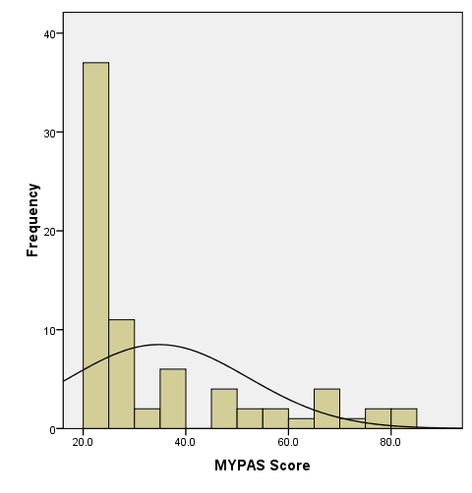 | 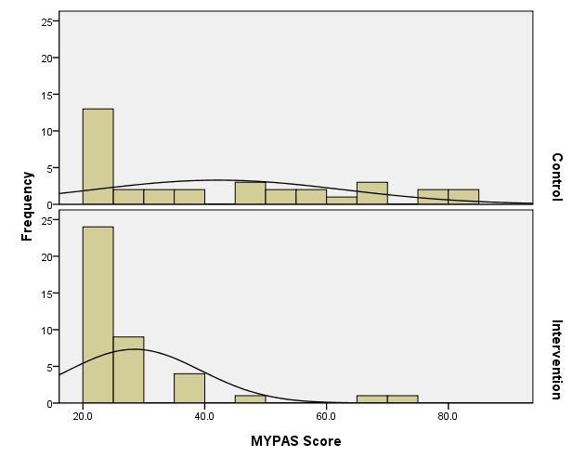

Post Hole 1—Use exploratory data analytic techniques to investigate the relationship between two variables.
Post Hole 4—Interpret a correlation matrix.

Explore MYPAS vs. Intervention: (A checklist is generally good, but interpret the magnitude with a careful sentence.)
*
Interpret the correlation matrix :
*

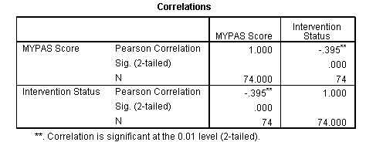

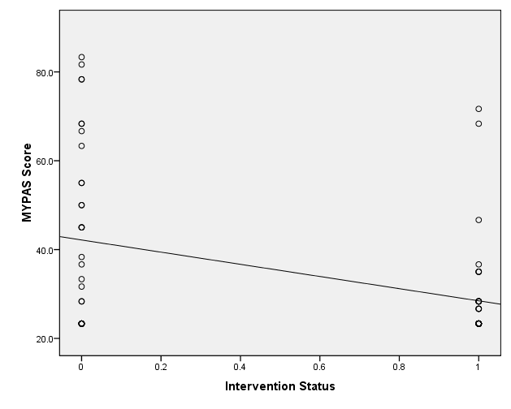

Post Hole 5—Interpret an R² statistic verbally and, using Boolean circles, graphically.
Post Hole 6—State the null hypothesis of a test for statistical significance; reject (or not) the null hypothesis; draw an inference (or not) from a sample to a population.
Post Hole 7—Interpret a confidence interval from a frequentist perspective and from a Bayesian perspective.
Post Hole 8—Evaluate the assumptions underlying a simple linear regression.
Interpret the R² statistic: (One careful sentence is good.)
outcome
predictor
*
Test for statistical significance: (Use the APA style.)
Blah blah blah, t(df) = xx.x, p < .xxx.
*
Interpret the confidence interval: (Use both perspectives.)
*
Evaluate the assumptions: (A checklist is good.)
*
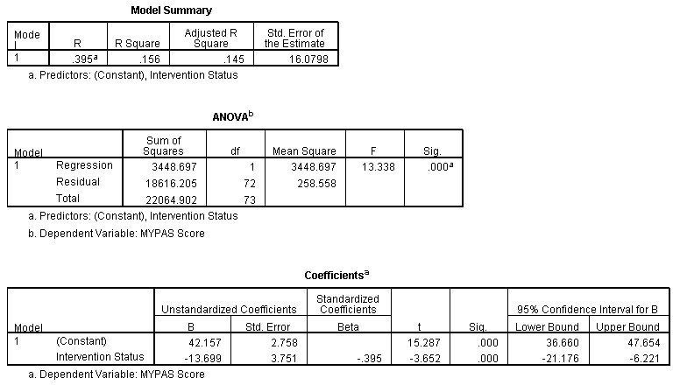

Post Hole A—Interpret a contingency table with chi-square statistic.

Interpret the contingency table: (Use the APA style.)
Blah blah blah, χ² (df) = xx.x, p = .xxx.
*
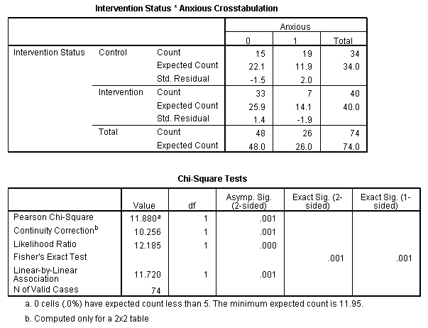

Post Hole 3—Conduct a z-score transformation by hand from a small data set.

MYPAS: 23 23 23 23 23 23 33 83
Please show your work:
*
Please note the mean of the raw distribution:
Please note the sum of squared mean deviations:
Please note the variance of the raw distribution:
Please note the standard deviation of the raw distribution:

MYPAS: 23 23 23 23 23 23 83 83
Please show your work:
*
Please note the mean of the raw distribution:
Please note the sum of squared mean deviations:
Please note the variance of the raw distribution:
Please note the standard deviation of the raw distribution:

Anxious: 0 0 0 0 0 0 1 1
Please show your work:
*
Please note the mean of the raw distribution:
Please note the sum of squared mean deviations:
Please note the variance of the raw distribution:
Please note the standard deviation of the raw distribution:

