EdStats.Org Introductory Mock Final Save As “Your_Name_Mock _Final.doc”

Data Set: These data are from Ferguson Middle School and its 187 graduating 8th grade students (anonymized).

Theory: If we can identify predictors of academic struggle in the sixth grade, we can use those predictors to help us target intervention programs for incoming middle schoolers. We will start with a performance measure and demographic variables.

Research Questions: We are sure that 6th grade math GPAs are positively correlated with 5th grade Math MCAS scores, but how strong is the correlation? Likewise, we are sure that, on average, students eligible for free lunch receive lower math grades, but how big is the gap? And, how big is the racial achievement gap?

Outcome: mathgpa6thgrade1stterm, continuous, Math grade point average (GPA) in the first term of 6th grade.

Predictors:
- mathmcas5th, continuous, 5th grade math score on the statewide test.
- freelunch, a dichotomy where free-lunch eligibility = 1, else 0.
- race, a polychotomy indicating a student’s self-identified race/etchnicity: 1 = Asian, 2 = Black, 3 = Latino, 4 = White
The corresponding indicator variables are asian, black and latino, with
white excluded to serve as a reference category.

For Future Reference

The final exam could use almost any dataset, but to avoid surprises we will focus on one dataset, the Ferguson Middle School (FMS) dataset (N = 187).

Whatever the dataset, the final will have one continuous outcome, one continuous predictor, one dichotomous predictor and one polychotomous predictor. There are many continuous, dichotomous and polychotomous variables in the FMS dataset:

Continuous Variables:

elamcas3rd  elamcas4th  elamcas5th  elamcas6th  elamcas7th  elamcas8th  mathmcas3rd  mathmcas4th  mathmcas5th  mathmcas6th  mathmcas7th  mathmcas8th | enggpa6thgrade1stterm  …  enggpa7thgrade1stterm  enggpat7thgrade2ndterm  enggpat7thgrade3rdterm  enggpatotal7th  …  enggpatotal8th  enggpatotal8th  mathgpatotal8th  scigpatotal8th  ssgpatotal8th | totalgpa6thgrade1stterm  totalgpa7thgrade2ndterm  totalgpa8thgrade3rdterm  totalgpa6th  totalgpa7th  totalgpa8th  absencescount6th  attendancepct7th  detentionscount8th  COMPOSITE SCORES  DIFFERENCE SCORES

Dichotomous Variables:

sped  music | freelunch  mathforward | esl  female

Polychotomous Variables:

race  team7th | elementaryschool  team8th | team6th  extracurriculars

# Here is the R syntax to obtain all the output for the final.
# Load your data.
# If your data is in Excel, save from Excel as a .csv file:
my.data <- read.csv('C:/my.folder/my.file.name.csv', header=TRUE)
# Fore more options: http://www.ats.ucla.edu/stat/r/faq/inputdata_R.htm
# Attach your data.
attach(my.data)

# Create dummy variables from polychotomous variables.
my.level.1 <- as.numeric(my.polychotomous.variable=='Level Name, Or Value-No-Quotes')
my.level.2 <- as.numeric(my.polychotomous.variable=='Level Name, Or Value-No-Quotes')
my.level.3 <- as.numeric(my.polychotomous.variable=='Level Name, Or Value-No-Quotes')

# Posthole 2
my.lovely.variables <- data.frame(my.continuous.outcome, my.continuous.predictor, my.dichotomous.predictor, my.polychotomous.predictor)
summary(my.lovely.variables)
hist(my.continuous.outcome, col='darkgrey')
hist(my.continuous.predictor, col='darkgrey')
hist(my.dichotomous.predictor, col='darkgrey')
plot(my.polychotomous.predictor, col='darkgrey')

# Posthole 4 & 1
my.numeric.vars <- data.frame(my.continuous.outcome, my.continuous.predictor,
my.dichotomous.predictor)
my.correlation.matrix <- cor(my.numeric.vars, use="pairwise.complete.obs")
round(my.correlation.matrix, digits=2)
my.model.1 <- lm(my.continuous.outcome ~ my.continuous.predictor)
plot(jitter(my.continuous.outcome) ~ my.continuous.predictor)
abline(my.model.1)
my.model.2 <- lm(my.continuous.outcome ~ my.dichotomous.predictor)
plot(my.continuous.outcome ~ jitter(my.dichotomous.predictor), col='grey')
points(my.continuous.outcome ~ my.dichotomous.predictor, pch=16)
abline(my.model.2)
my.model.3 <- lm(my.continuous.predictor ~ my.dichotomous.predictor)
plot(my.continuous.predictor ~ jitter(my.dichotomous.predictor), col='grey')
points(my.continuous.predictor ~ my.dichotomous.predictor, pch=16)
abline(my.model.3)

# Postholes 5, 6, 7 & 8
my.model.4 <- lm(my.continuous.outcome ~ my.continuous.predictor)
summary(my.model.4)
confint(my.model.4)
plot(my.continuous.outcome ~ my.continuous.predictor)
abline(my.model.4)
# You may want to jitter one or both variables.
plot(jitter(my.continuous.outcome) ~ my.continuous.predictor)
abline(my.model.4)

# Postholes 5, 6, 7 & 8
abline(my.model.5) <- lm(my.continuous.outcome ~ my.dichotomous.predictor)
summary(my.model.5)
confint(my.model.5)
plot(my.continuous.outcome ~ my.dichotomous.predictor)
abline(my.model.5)
# You may want to jitter one or both variables (and overlay the original points).
plot(my.continuous.outcome ~ jitter(my.dichotomous.predictor), col='grey')
points(my.continuous.outcome ~ my.dichotomous.predictor, pch=16)
abline(my.model.5)

# Postholes 9 & 8
my.model.6 <- lm(my.continuous.outcome ~ my.level.1 + my.level.2 + my.level.3)
summary(my.model.6)
confint(my.model.6)
plot(my.continuous.outcome ~ my.polychotomous.predictor)

# Postholes 10 & 8
my.model.7 <- lm(my.continuous.outcome ~ my.dichotomous.predictor*my.polychotomous.predictor)
anova(gpa.on.fl.and.my.polychotomous.predictor) # Default "Type I" Sum of Squares
# "Type I" has different nulls for first and second main effects.
# "Type III" has same null for all main effects:
# Within factor, all levels have same mean outcome in population.
# For "Type III" use orthogonal contrasts and drop1 function.
contrasts(my.polychotomous.predictor) <- contr.sum(4) # Reset contrast from default.
# When resetting, make sure you specify the correct number of levels. Here, 4 levels.
# Make sure your predictor is a factor.
my.dichotomous.predictor <- as.factor(my.dichotomous.predictor)
contrasts(my.dichotomous.predictor) <- contr.sum(2) # Reset contrast from default.
my.model.8 <- lm(my.continuous.outcome ~ my.dichotomous.predictor*my.polychotomous.predictor)
drop1(my.model.8, ~., test='F') # ANOVA table with "Type III" SS.
plot(resid(my.model.8)~predict(my.model.8))
abline(h=0) # Drop a horizontal reference line.
mean.rm.na <- function(x) {mean(x, na.rm=TRUE)} # Remove missing.
interaction.plot(my.polychotomous.predictor, my.dichotomous.predictor,
my.continuous.outcome, fun=mean.rm.na)

# Posthole A
observed.count.table <- table(my.dichotomous.predictor, my.polychotomous.predictor)
expected.count.table <- (as.array(margin.table(observed.count.table, 1))
%*% t(as.array(margin.table(observed.count.table, 2)))
/ margin.table(observed.count.table))
st.res <- function(o, e) {(o-e)/sqrt(e)}
standardized.residual.table <- st.res(observed.count.table, expected.count.table)
observed.count.table
round(expected.count.table, digits=0)
round(standardized.residual.table, digits=0)
summary(observed.count.table)

detach(my.data)

Post Hole 2—Use exploratory data analytic techniques to describe the distribution of a variable.

Explore mathgpa6thgrade1stterm: (A checklist is good.)
*
Explore mathmcas5th: (A checklist is good.)
*
Explore freelunch: (A checklist is good.)
*
Explore race: (A checklist is good.)
*

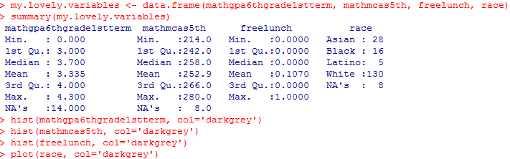

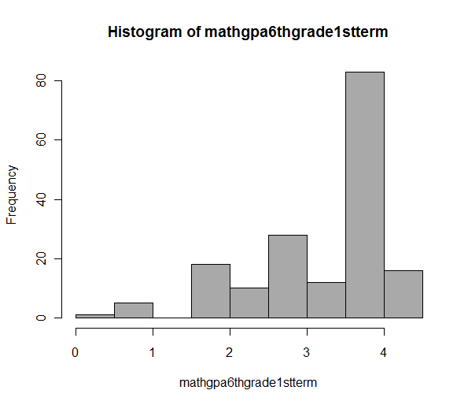 | 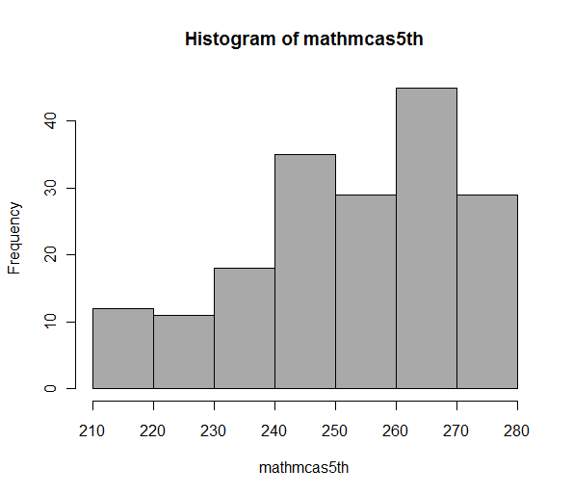
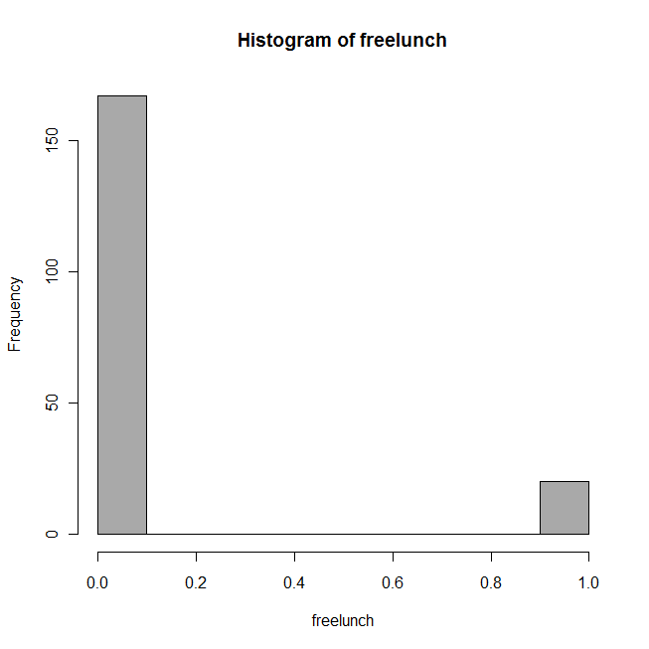 | 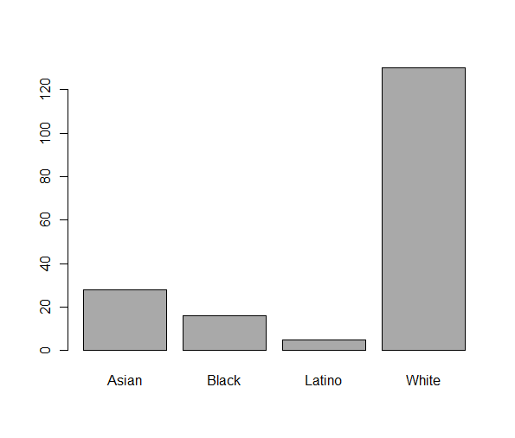

Post Hole 1—Use exploratory data analytic techniques to investigate the relationship between two variables.
Post Hole 4—Interpret a correlation matrix.

Explore mathgpa6thgrade1stterm vs. mathmcas5th: (A checklist is generally good, but interpret the magnitude with a careful sentence.)
*
Explore mathgpa6thgrade1stterm vs. freelunch: (A checklist is generally good, but interpret the magnitude with a careful sentence.)
*
Interpret the correlation matrix :
*
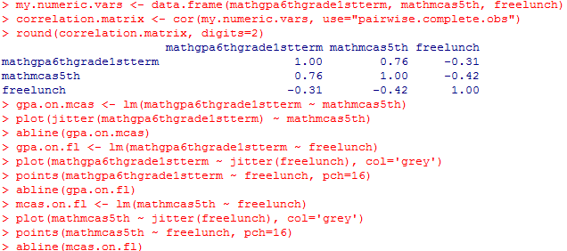

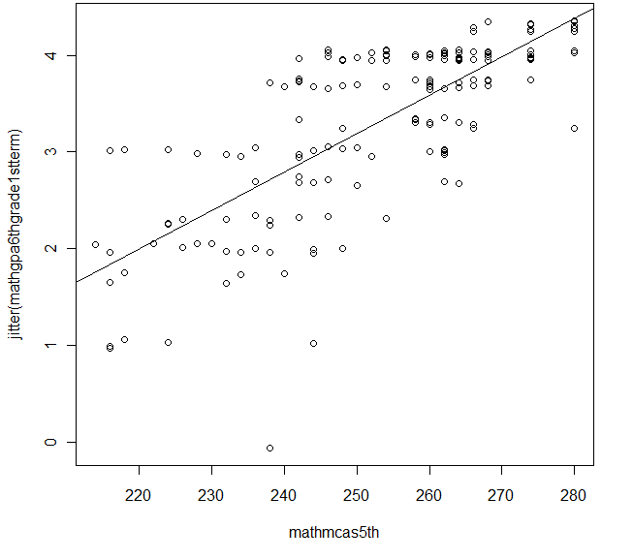

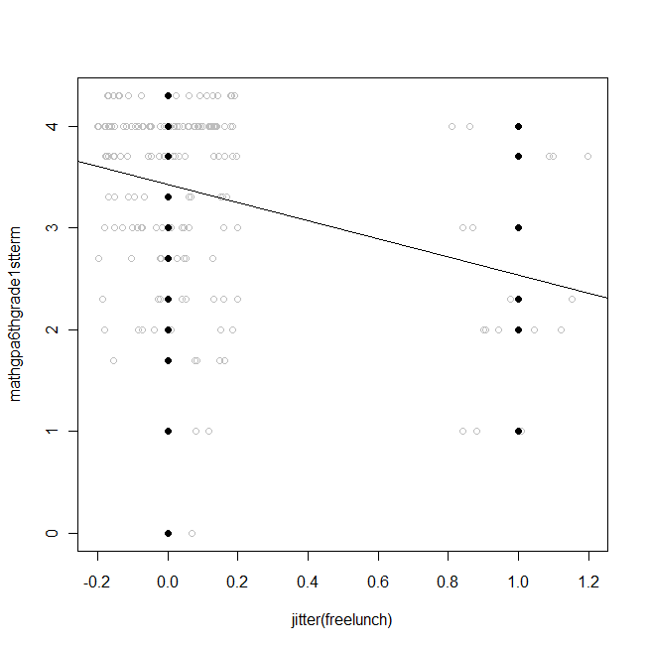

Here is the relationship between the two predictors. You do not need to conduct exploratory data analysis on this relationship, but you do want to check it before you interpret the Pearson correlation. | 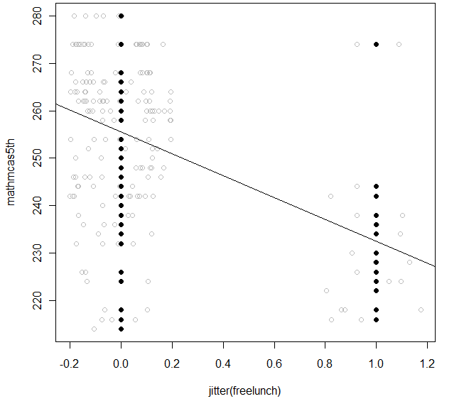

Post Hole 5—Interpret an R² statistic verbally and, using Boolean circles, graphically.
Post Hole 6—State the null hypothesis of a test for statistical significance; reject (or not) the null hypothesis; draw an inference (or not) from a sample to a population.
Post Hole 7—Interpret a confidence interval from a frequentist perspective and from a Bayesian perspective.
Post Hole 8—Evaluate the assumptions underlying a simple linear regression.
Interpret the R² statistic: (One careful sentence is good.)
outcome
predictor
*
Test for statistical significance:
*
Interpret the confidence interval: (Use both perspectives.)
*
Evaluate the assumptions: (A checklist is good.)
*

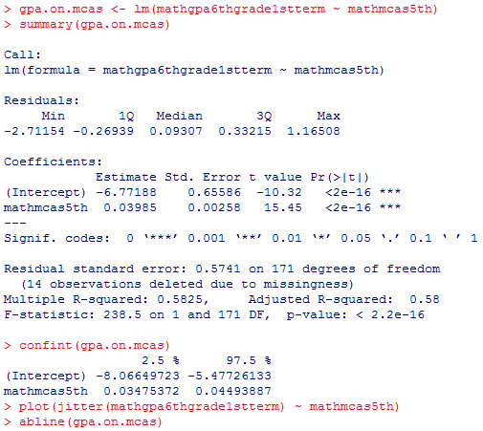

Post Hole 5—Interpret an R² statistic verbally and, using Boolean circles, graphically.
Post Hole 6—State the null hypothesis of a test for statistical significance; reject (or not) the null hypothesis; draw an inference (or not) from a sample to a population.
Post Hole 7—Interpret a confidence interval from a frequentist perspective and from a Bayesian perspective.
Post Hole 8—Evaluate the assumptions underlying a simple linear regression.
Interpret the R² statistic: (One careful sentence is good.)
outcome
predictor
*
Test for statistical significance: (Use the APA style.)
Blah blah blah, t(df) = xx.x, p < .xxx.
*
Interpret the confidence interval: (Use both perspectives.)
*
Evaluate the assumptions: (A checklist is good.)
*
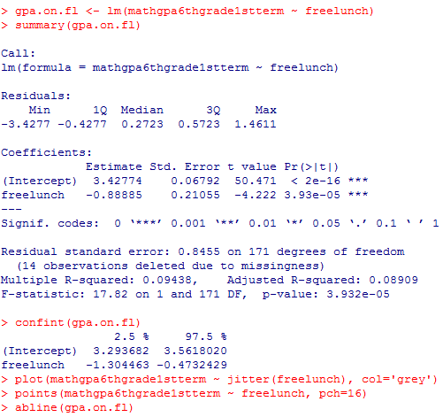
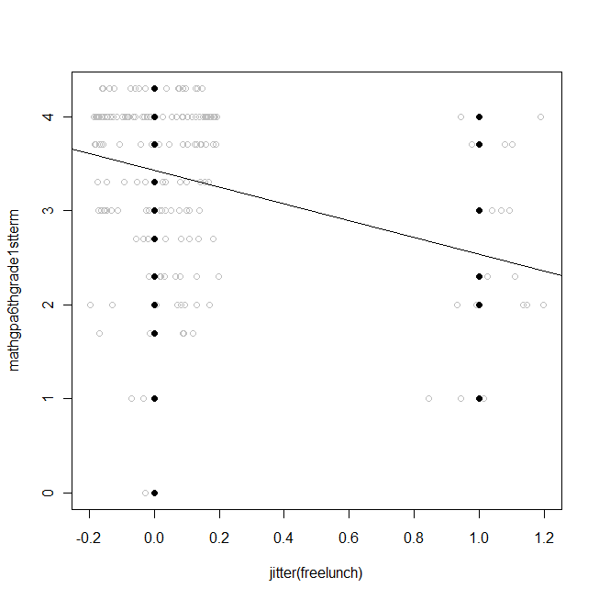

Post Hole 9—Interpret the parameter estimates and F-test from regressing a continuous variable on a set of dummy variables.
Post Hole 8—Evaluate the assumptions.

Interpret the parameter estimates and F-test: (Use the APA style.)
Blah blah blah, F(df_{between}, df_{within}) = xx.x, p < .xxx, η² =.xxx.
*
Evaluate the assumptions: (A checklist is good.)
*
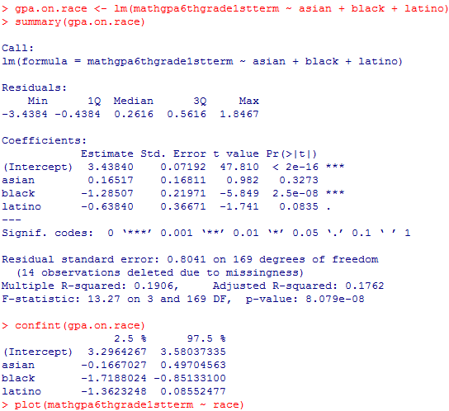
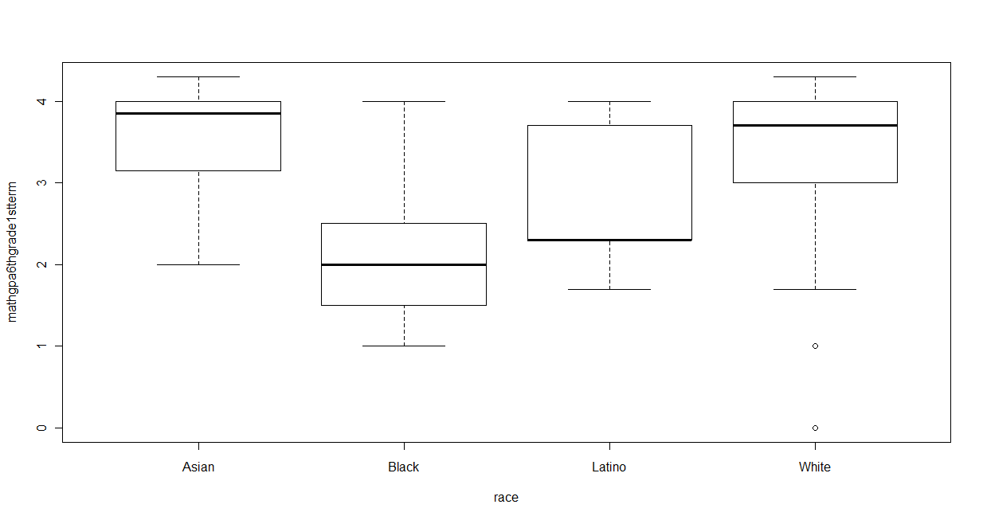

Post Hole 10—Interpret a two-way analysis of variance using F-tests and graphs.
Post Hole 8—Evaluate the assumptions.

Interpret the two-way ANOVA: (Fully interpret at least one F-test,
using the APA style. Mention the F-tests that you do not fully interpret.)
Blah blah blah, F(df_{between}, df_{within}) = xx.x, p < .xxx, η² =.xxx.
*
Evaluate the assumptions: (A checklist is good.)
*

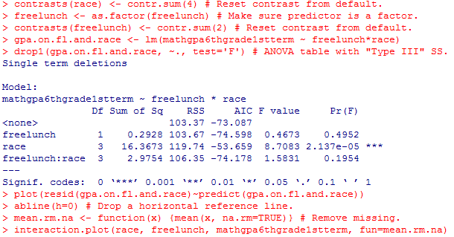
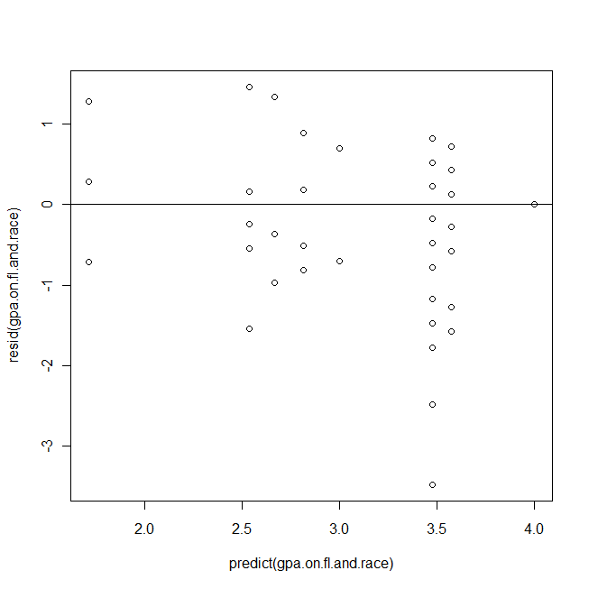 | 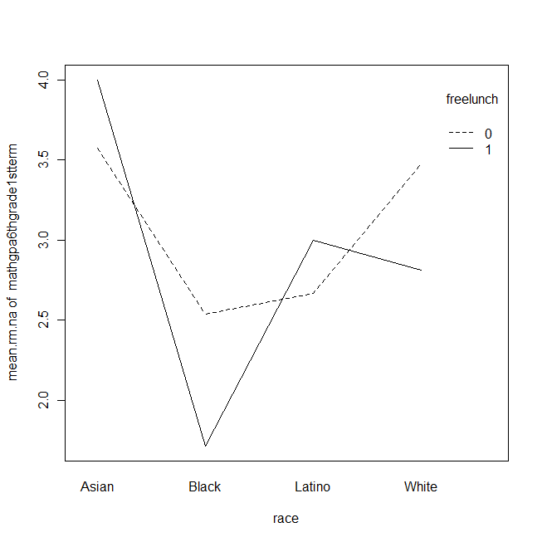

Post Hole A—Interpret a contingency table with chi-square statistic.

Interpret the contingency table: (Use the APA style.)
Blah blah blah, χ² (df) = xx.x, p = .xxx.
*
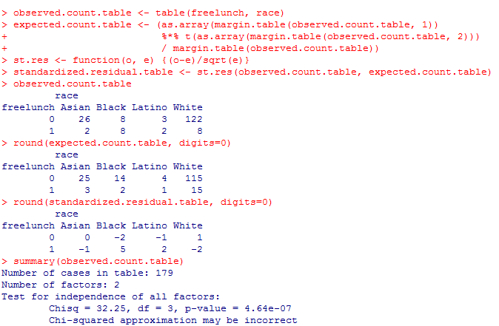

Post Hole 3—Conduct a z-score transformation by hand from a small data set.

GPAs: 4 0 4 3 3 4 2 2 4 4

Please show your work:
*
Please note the mean of the raw distribution:
Please note the sum of squared mean deviations:
Please note the variance of the raw distribution:
Please note the standard deviation of the raw distribution:

