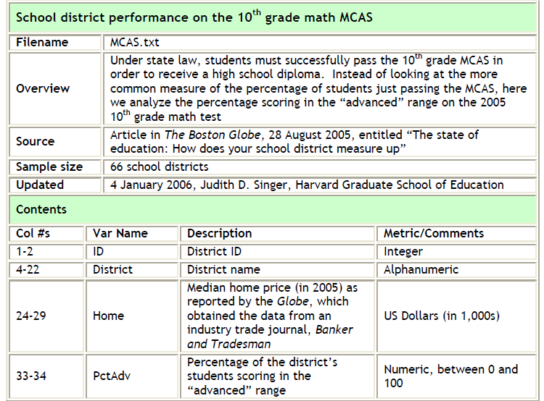

Theory: Wealthier communities will have greater percentages of high academic achievers because they have the educational resources to support intensive learning.
Research Question: Is a school district’s median home value positively correlated with the percentage of 10th graders scoring “Advanced” on the Mathematics MCAS?
Outcome: PctAdv, (continuous and ratio)
Predictor: Home, (continuous and ratio)

Post Hole 2—Use exploratory data analytic techniques to describe the distribution of a variable.

Explore Home: (A checklist is good.)
*
Explore PctAdv: (A checklist is good.)
*
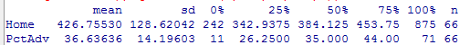

Post Hole 1—Use exploratory data analytic techniques to investigate the relationship between two variables.

Explore PctAdv vs. Home: (A checklist is generally good, but interpret the magnitude with a careful sentence.)
*
