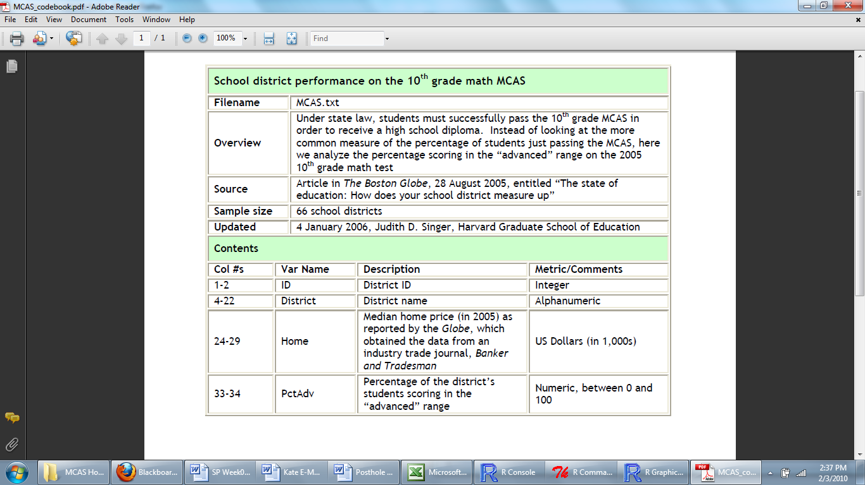

Theory: Wealthier communities will have greater percentages of high academic achievers because they have the educational resources to support intensive learning.
Research Question: Is a school district’s median home value positively correlated with the percentage of 10th graders scoring “Advanced” on the Mathematics MCAS?
Outcome: PctAdv, (continuous and ratio)
Predictor: Home, (continuous and ratio)

Post Hole 2—Use exploratory data analytic techniques to describe the distribution of a variable.

Explore Home: (A checklist is good.)
Spread: (Note: R and SPSS give slightly different values for the percentiles. As I mentioned in the lecture, there are slightly different ways to think about percentiles, and R and SPSS come down on different sides of the fence! From an exploratory, “soft eyes,” perspective, it doesn’t matter).
For R, the midspread is 111. There are some positive outliers based on 1.5 midspread whiskers, where the RUB is 620 (111*1.5+454) which is less than the max of 875. There are no negative outliers.
For SPSS, the midspread is 118. There are some positive outliers based on 1.5 midspread whiskers, where the RUB is 636 which is less than the max of 875. There are no negative outliers.
Location: The median median (sic!) home value is 384.
Shape: Positively Skewed
*
Explore PctAdv: (A checklist is good.)
Spread: For R, 17.75 midspread, no outliers, RUB is greater than the max, and the RLB is less than the min. For SPSS, 18.5 midspread, no outliers, RUB is greater than the max, and the RLB is less than the min.
Location: The median PctAdv is 35.
Shape: Positively Skewed
*
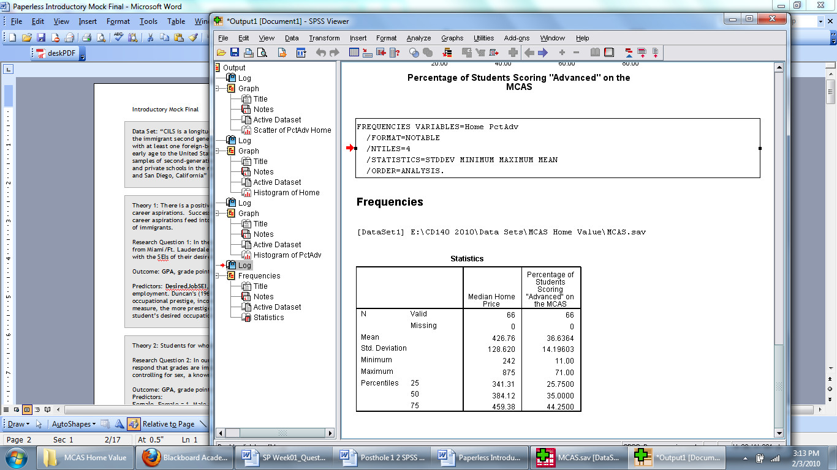
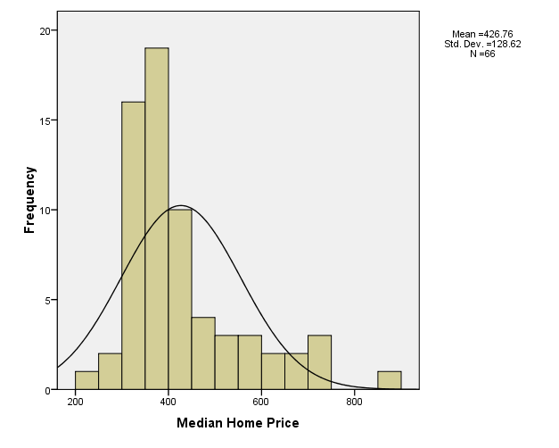 | 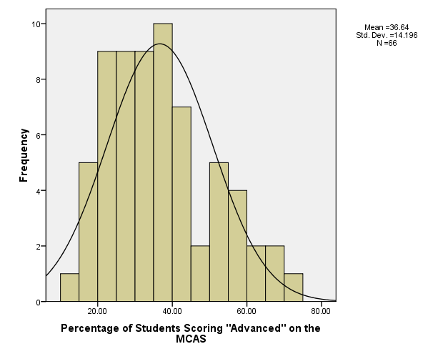

Post Hole 1—Use exploratory data analytic techniques to investigate the relationship between two variables.

Explore PctAdv vs. Home: (A checklist is generally good, but interpret the magnitude with a careful sentence.)
Direction: Positive
Outliers: Yes, one community with expensive homes but few advanced.
Linearity: Non-Linear
Magnitude: Big, especially at lower home values.
Strength: Data hug curve moderately.
(Notes: The outlier is Cambridge. Do you see how Cambridge is not an outlier for PctAdv? Cambridge is an outlier for Home, but it’s not the most extreme outlier. In general, univariate outliers need not be bivariate outliers, nor vice versa!)
*
*