Data Set: “The Early Childhood Longitudinal Study, Kindergarten Class of 1998-99 (ECLS-K) focuses on children's early school experiences beginning with kindergarten and following children through middle school. The ECLS-K data provide descriptive information on children's status at entry to school, their transition into school, and their progression through 8th grade. The longitudinal nature of the ECLS-K data enables researchers to study how a wide range of family, school, community, and individual factors are associated with school performance.” (from the website description of the data set).

Theory: Even at the earliest stages of formal education, SES gaps exist in standardized test scores.

Research Question: Are first grade math scores positively correlated with socioeconomic status?

Outcome: MATHS1, an IRT scaled math score from spring first grade
Question Predictor: ZSES, a standardized measure of socioeconomic status

Post Hole 3—Conduct a z-score transformation by hand from a small data set.

Math Scores: 58 40 46 44 40 52 43 36 48 53

Please show your work:
*
Please note the mean of the raw distribution:
Please note the sum of squared mean deviations:
Please note the variance of the raw distribution:
Please note the standard deviation of the raw distribution:

Post Hole 2—Use exploratory data analytic techniques to describe the distribution of a variable.

Explore MATHS1: (A checklist is good.)
*

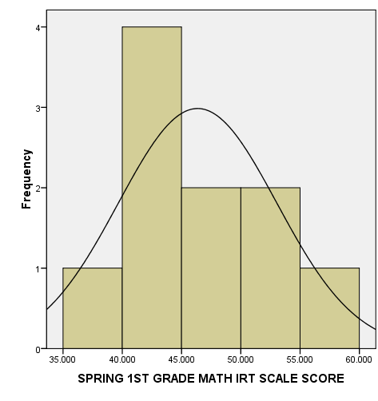 | 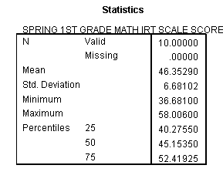

Post Hole 1—Use exploratory data analytic techniques to investigate the relationship between two variables.

Explore MATHS1 vs. ZSES: (A checklist is generally good, but interpret the magnitude with a careful sentence.)
*
