College graduation rates in public and private US colleges and universities
Filename | Gradrate.txt
Overview | What predicts college graduation rates in public and private US colleges and universities and do the effects of these predictors differ in public and private institutions?
Source | Scott, M, Bailey, T, & Kienzl, G (2006). Relative success: Determinants of college graduation rates in public and private colleges in the US, Research in Higher Education, 47(1)  (This data set and codebook are by way of Judith D. Singer, Harvard Graduate School of Education. Notice that Singer asks about predictors of college graduation rates, whereas Scott, Bailey and Kienzl ask about determinants of college graduate rates. Singer is adeptly avoiding unwarranted causal language.)
Sample size | 1621 colleges and universities

Theory: Highly selective colleges will graduate more students because their students are better equipped to handle the academic rigors of college.

Research Question: Is there a positive correlation between schools’ six-year graduation rates and SAT scores, represented by the 75th percentile at each school?

Outcome Variable:
PctGrad | Institution’s six-year graduation rate in 1997, defined as the percentage of the full-time freshmen class entering in 1991 that had graduated by 1997 | Numeric
Predictor Variable:
SAT75thPercentile | The 75th percentile of the incoming freshmen SAT scores
Other Variables:
Public | Institutional status | 0 = private  1 = public
SATMidspread | Interquartile range of the incoming freshmen SAT scores (ie, the difference between the 75th and 25th percentiles)
FinAid | Percentage of students receiving financial aid | Numeric

Post Hole 3—Conduct a z-score transformation by hand from a small data set.

Graduation Rates: 60 50 40 60 50 40 50 70 30

Please show your work:
Raw | Mean | Deviation | Deviation Sq | Z
30 | 50 | -20 | 400 | -1.63299
40 | 50 | -10 | 100 | -0.8165
40 | 50 | -10 | 100 | -0.8165
50 | 50 | 0 | 0 | 0
50 | 50 | 0 | 0 | 0
50 | 50 | 0 | 0 | 0
60 | 50 | 10 | 100 | 0.816496
60 | 50 | 10 | 100 | 0.816496
70 | 50 | 20 | 400 | 1.632993

*
Please note the mean of the raw distribution: | 50
Please note the sum of squared mean deviations: | 1200
Please note the variance of the raw distribution: | 150
Please note the standard deviation of the raw distribution: | 12.247

Post Hole 5—Interpret an R² statistic verbally and, using Boolean circles, graphically.
Post Hole 1—Use exploratory data analytic techniques to investigate the relationship between two variables.
Interpret the R² statistic: (One careful sentence is good.)
SAT predicts 56% of the variation in PctGrad. | PctGrad  SAT
*
Explore PctGrad vs. SAT75thPercentile: (A checklist is generally good, but interpret the magnitude with a careful sentence.)
Direction: Positive
Outliers: Eh, okay. Some interesting schools, but nothing scary.
Linearity: Linear (Or Perhaps a Gentle “S” Curve ?!?)
Magnitude: If two schools differ in SAT75thPercentile by 100 points, we predict that the more selective school will have a higher graduation rate by about 9 percentage points.
Strength: Strong.
*
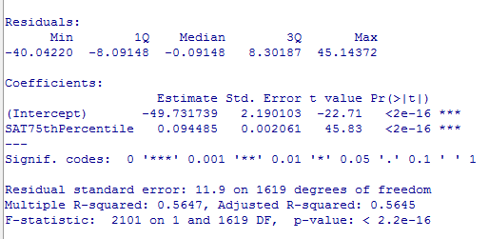

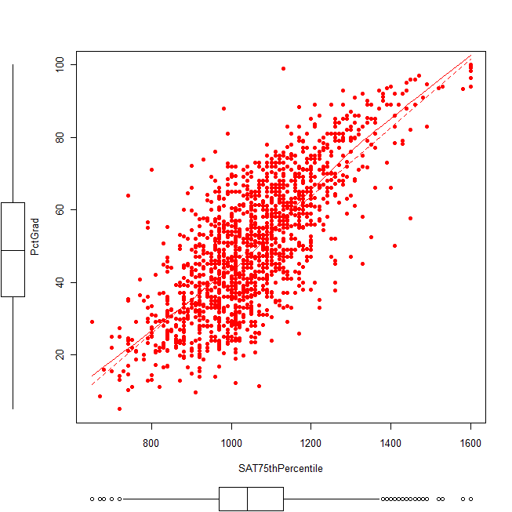

Post Hole 4—Interpret a correlation matrix.

Interpret the correlation matrix :
SAT75th has a strong positive relationship with PctGrad (r = .75). Interestingly, schools with more varying SATs tend to graduate fewer students, but this is a moderate to weak correlation comparitively (r = -.27). Surprisingly, FinAid has virtually no relationship with PctGrad (r = .03).

The predictors are barely, if at all, correlated with one another.
*
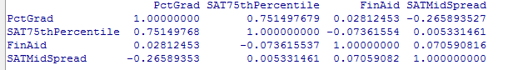
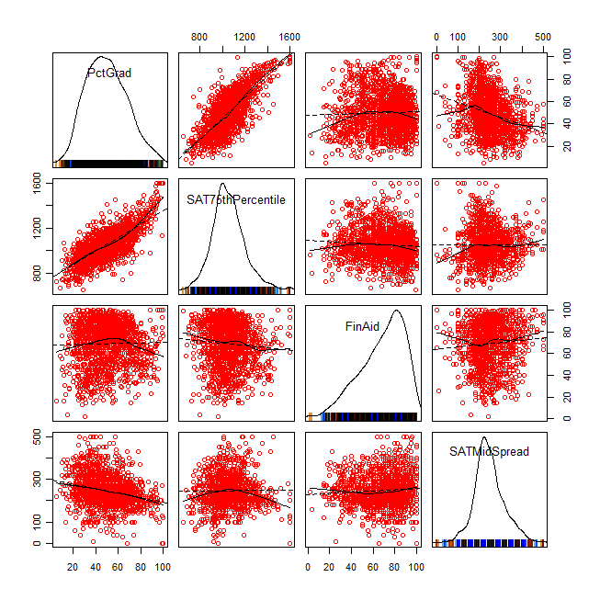

Post Hole 2—Use exploratory data analytic techniques to describe the distribution of a variable.

Explore PctGrad: (A checklist is good.)
Spread: Midspread of 26. Whiskers length 39, reaching up to 101 and down to -3, but we trim them at the max 100 and the min 5, and conclude no outliers.
Location: 49 median.
Shape: Roughly symmetrical, maybe a tiny bit flat.
*
Explore SAT75thPercentile: (A checklist is good.)
Spread: Midspread of 160. Whiskers length 240, reaching up to 1370 and down to 730, so we suspect a bunch of outliers in both directions.
Location: 1040 median.
Shape: Roughly symmetrical, a bit peaky. Slight positive skew.
*
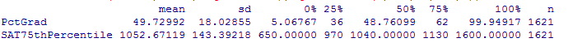
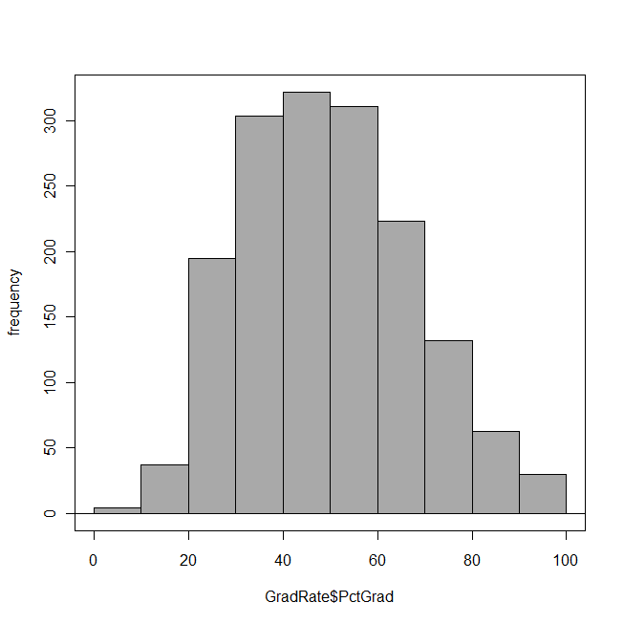 | 