California Test Scores (Elementary Schools)
Filename | CaliforniaElementarySchools.sav
Overview | What predicts test scores in California elementary schools?
Source | The California Standardized Testing and Reporting (STAR)) dataset contains data on test performance, school characteristics and student demographic backgrounds. The data used here are from all 420 K-6 and K-8 districts in California with data available for 1998 and 1999. Test scores are the average of the reading and math scores on the Stanford 9 standardized test administered to 5th grade students. School characteristics (averaged across the district) include enrollment, number of teachers (measured as “full-time-equivalents”), number of computers per classroom, and expenditures per student. The student-teacher ratio used here is the number of full-time equivalent teachers in the district, divided by the number of students. Demographic variables for the students also are averaged across the district. The demographic variables include the percentage of students in the public assistance program CalWorks (formerly AFDC), the percentage of students that qualify for a reduced price lunch, and the percentage of students that are English Learners (that is, students for whom English is a second language). All of these data were obtained from the California Department of Education (www.cde.ca.gov). (The original codebook was written by Mark Watson of Princeton University, who also made this data set available.)
Sample size | 174 California Elementary Schools

Theory: Small class sizes are conducive to learning because they provide students the one-on-one attention they need for optimized learning.

Research Question: In the population of California elementary schools, is there a negative correlation between student-teacher ratio and math scores?

Outcome Variable:
MathScores | School-wide average math scores. | Numeric
Predictor Variable:
StudentTeacherRatio | Ratio of students to teachers. | Numeric
Other Variables:
Expenditure | Expenditure per student (in dollars) | Numeric
Computers | Computers per student | Numeric
AverageIncome | Average income in the school district. | Numeric

Post Hole 1—Use exploratory data analytic techniques to investigate the relationship between two variables.

Explore Average Math Test Scores vs. Student-Teacher Ratio: (A checklist is generally good, but interpret the magnitude with a careful sentence.)
*
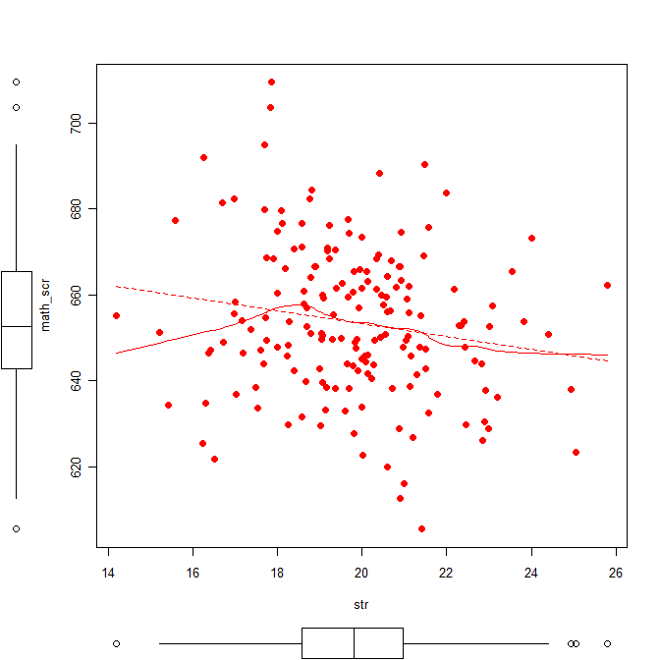

Post Hole 5—Interpret an R² statistic verbally and, using Boolean circles, graphically.
Post Hole 6—State the null hypothesis of a test for statistical significance; reject (or not) the null hypothesis; draw an inference (or not) from a sample to a population.
Interpret the R² statistic: (One careful sentence is good.)
Outcome
Predictor
*
Test for statistical significance:
*

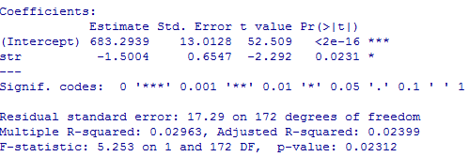

Post Hole 4—Interpret a correlation matrix.

Interpret the correlation matrix :
*
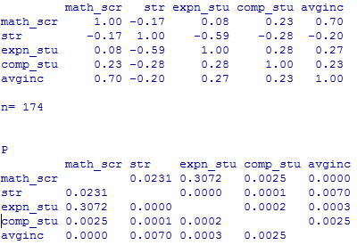

Test for statistical significance: This is slightly different from the final, but this will demonstrate two things. First, correlations have p-values for testing statistical significance, which makes sense because correlations are just standardized slopes, so if slopes have p-values, then correlations must have p-values (in fact the same p-values!). Second, not all relationships are statistically significant, and we need to be able to interpret tests for statistical significance even when they turn up negative. To that end, test the statistical significance of the linear relationship between per pupil expenditure (expn_stu) and math scores (math_scr), where r = 0.08 and p = 0.3072.
*

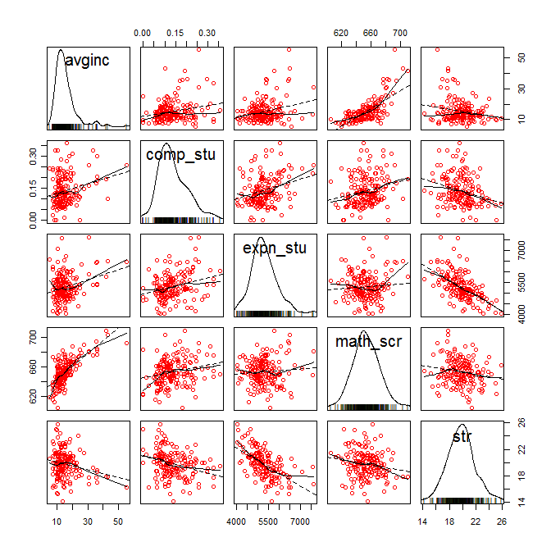

Post Hole 2—Use exploratory data analytic techniques to describe the distribution of a variable.

Explore Average Math Scores: (A checklist is good.)
*
Explore Student-Teacher Ratio: (A checklist is good.)
*
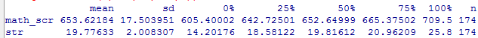
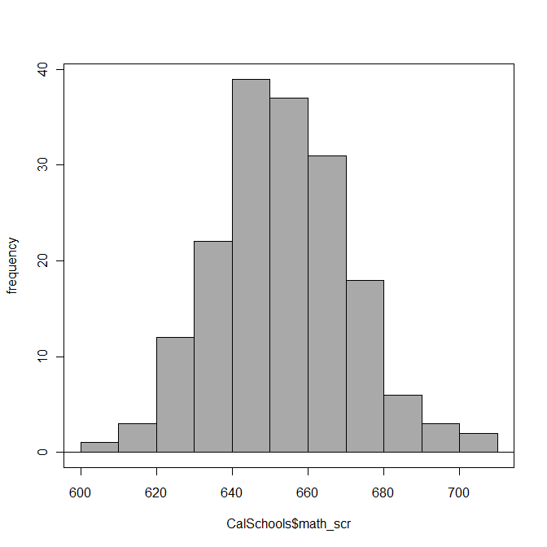 | 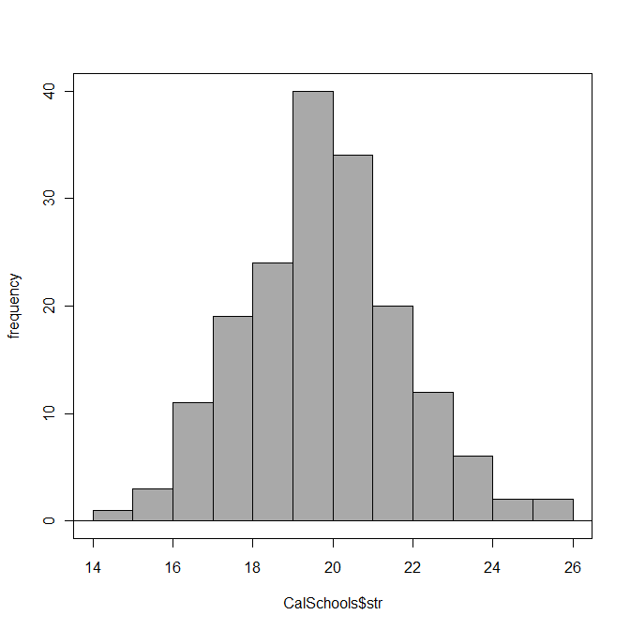

Post Hole 3—Conduct a z-score transformation by hand from a small data set.

Student-Teacher Ratios: 20 15 25 20 17.5 17.5 20 22.5 22.5

Please show your work:
*
Please note the mean of the raw distribution:
Please note the sum of squared mean deviations:
Please note the variance of the raw distribution:
Please note the standard deviation of the raw distribution:

