Tennessee's K-3 Class Size Study
Filename | star.sav
Overview | The Student/Teacher Achievement Ratio (STAR) was a four-year longitudinal class-size study funded by the Tennessee General Assembly and conducted by the State Department of Education. Over 7,000 students in 79 schools were randomly assigned into one of three interventions: small class (13 to 17 students per teacher), regular class (22 to 25 students per teacher), and regular-with-aide class (22 to 25 students with a full-time teacher's aide). Classroom teachers were also randomly assigned to the classes they would teach. The interventions were initiated as the students entered school in kindergarten and continued through third grade.
Source | http://www.heros-inc.org/star.htm
Sample size | 2030 students who were randomly assigned to small classes (n = 1293) or regular classes (n = 737) during both kindergarten and first grade.

Theory: Small class sizes are conducive to learning because they provide students the one-on-one attention they need for optimized learning.

Research Question: In the population of Tennessee early elementary schoolers, does attending small classes in kindergarten and first grade improve first grade test scores? (Note: we can ask, and answer, a causal question because students were randomized into small and regular class. Because of the randomization, the two groups begin equal in expectation. If they finish different, then that difference is reasonably attributable to the experimental condition.)

Outcome Variable:
TOTAL1 | 1st grade reading and math scores combined | Numeric
Predictor Variable:
SMALLK1 | 1 = the student was assigned to small classes K-3  0 = the student was assigned to regular classes K-3 | Categorical
Other Variables:
READ1 | 1st grade reading scores | Numeric
MATH1 | 1st grade math scores | Numeric

Post Hole 1—Use exploratory data analytic techniques to investigate the relationship between two variables.

Explore TOTAL1 vs. SMALLK1: (A checklist is generally good, but interpret the magnitude with a careful sentence.)
Direction: Positive
Outliers: There appears to be high outliers in both groups.
Linearity: Necessarily
Magnitude: On average, students in small classes score 31 points higher on the 1st grade composite test than students in regular classes.
Strength: Weak
*
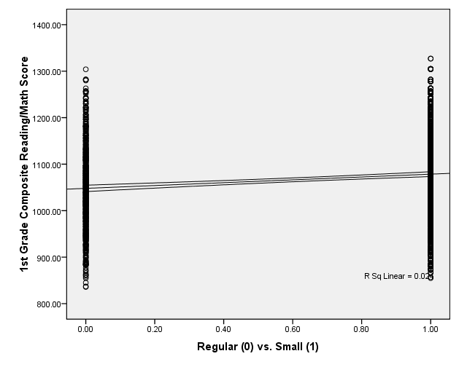 | 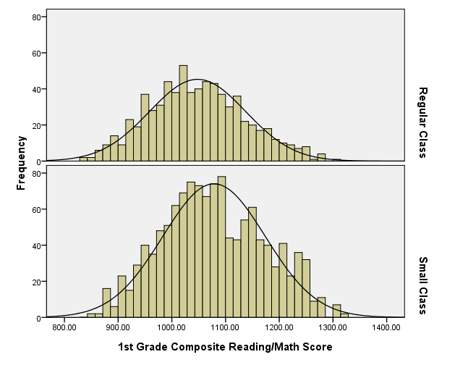

Post Hole 5—Interpret an R² statistic verbally and, using Boolean circles, graphically.
Post Hole 6—State the null hypothesis of a test for statistical significance; reject (or not) the null hypothesis; draw an inference (or not) from a sample to a population.
Post Hole 7—Interpret a confidence interval from a frequentist perspective and from a Bayesian perspective.
Post Hole 8—Evaluate the assumptions underlying a simple linear regression.
Interpret the R² statistic: (One careful sentence is good.)
SMALLK1 predicts about 2.4% of the variation in READING3. | READING3  SMALLK1
*
Test for statistical significance:
The null hypothesis is that there is no relationship in the population. If the null were true, we would expect to observe a relationship as extreme (or more extreme) as ours less than 0.1% of the time. Therefore, we reject the null hypothesis, and we conclude that, in the population of Tennessee 1st grade students, students from smaller classes score higher on average than students from regular classes. (FYI: Because of the randomized intervention/control design of this study, we can draw a causal conclusion. Consequently, we can say that small class sizes improve test scores.)
*
Interpret the confidence interval: (Use both perspectives.)
22 to 39 provides a range of plausible values for the population average effect of small class sizes. Over the course of our lives, only 95% of such ranges will actually contain the population parameter.

In the absence of further information, we are 95% confident that the true average effect of small class sizes on 1st grade composite test scores is between 22 and 39 in the population.
*
Evaluate the assumptions: (A checklist is good.)
Homoscedasticity: Good. The two groups have roughly equal variances. No funnel.
Independence: Shady. Clustering within classroom within schools.
Normality: Good. The two groups are distributed roughly normally.
Linearity: Necessarily.
Outliers: Good. There are slight, slight upper outliers, but they won’t have much influence with such a large sample size.
*

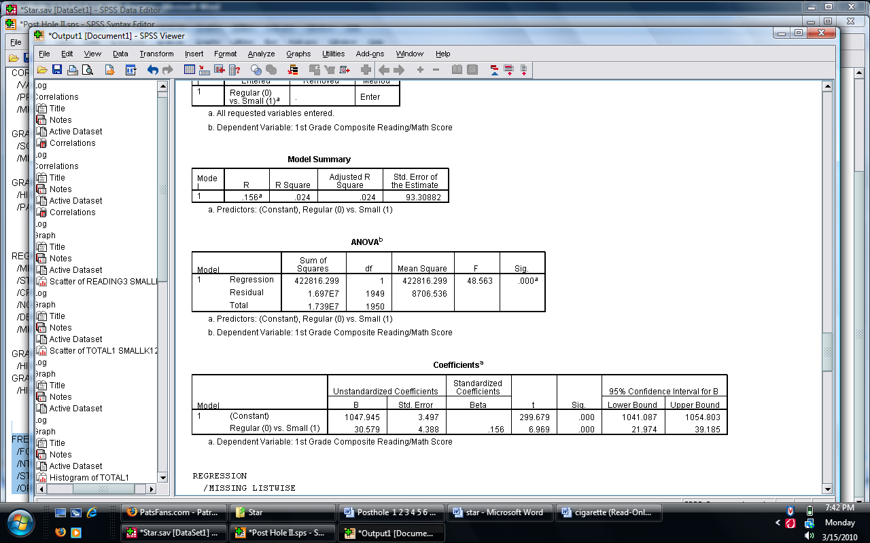

Post Hole 4—Interpret a correlation matrix.

Interpret the correlation matrix :
The three correlations between scores (composite, reading, and math, respectively) and the treatment/intervention variable are all around 0.15 and statistically significant. I wonder about practical significance. Is this strong enough to justify the costs of smaller class sizes?

The reading test and math test are highly correlated with the composite test. This makes sense because each subtest is part of the composite test, and, of course, each subtest is perfectly correlated with itself. The reading and math test are highly correlated with one another, which is expected for tests of cognitive proficiency.
*
Extra credit if you can figure out why the composite, TOTAL1, has a higher correlation with the intervention than either subtest, READ1 or MATH1, have with the intervention!

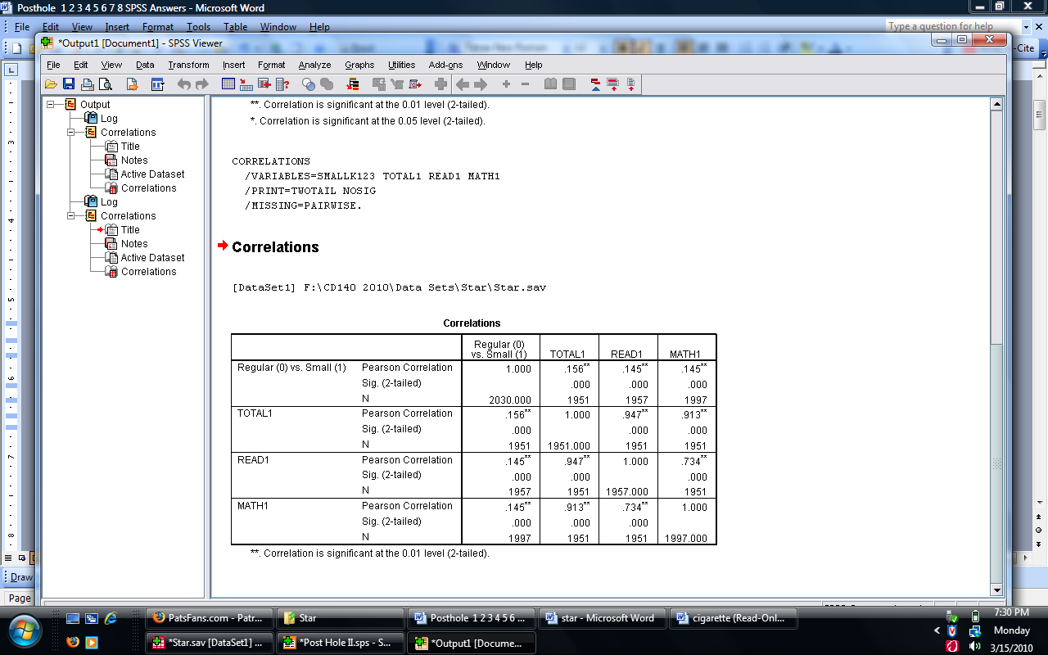

Post Hole 2—Use exploratory data analytic techniques to describe the distribution of a variable.

Explore READING3: (A checklist is good.)
Spread: Midspread = 133, Whiskers = 199, RLB = 801, RUB = 1332. No outliers. Everybody looks like they are part of the bell curve.
Location: Median = 1062
Shape: Roughly normal
*
Explore SMALLK1: (A checklist is good.)
63.7% of students were assigned to small classes. 36.3% of students were assigned to regular classes.
*
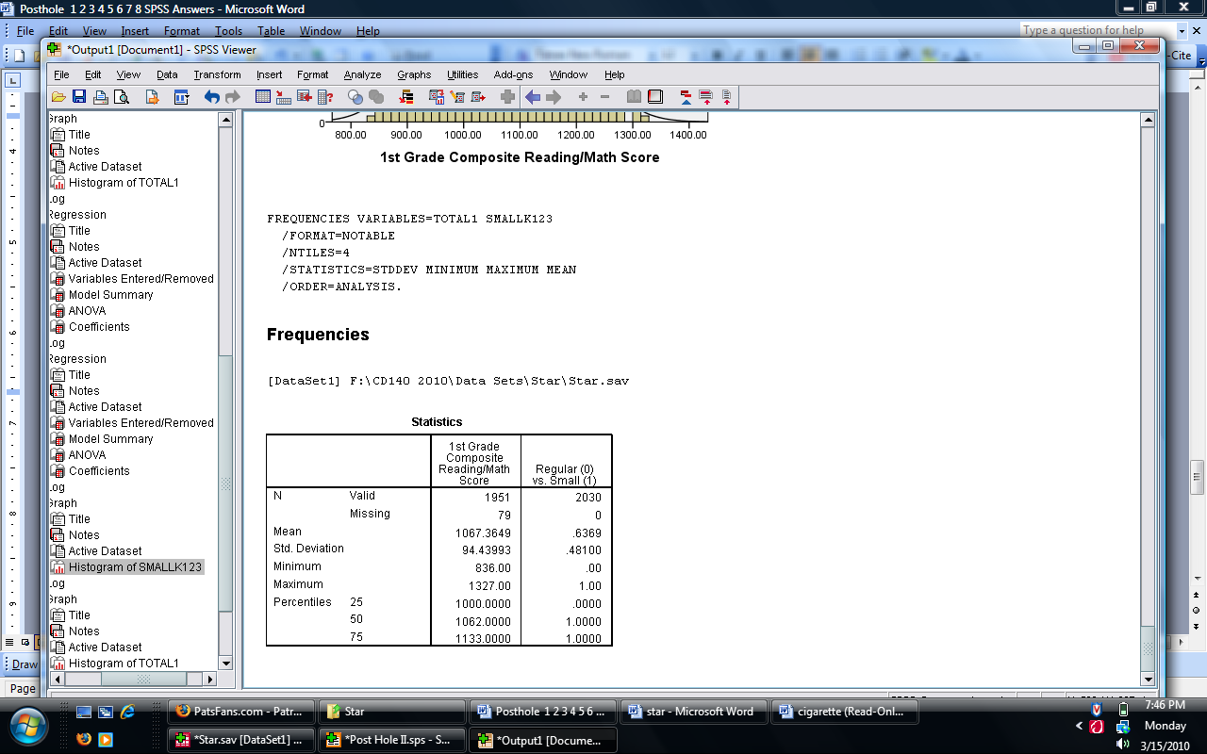
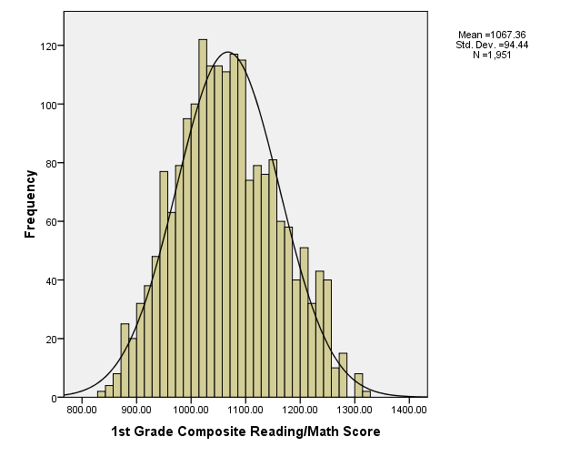 | 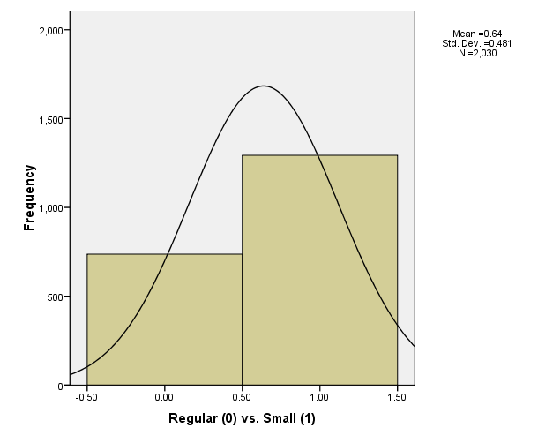

Post Hole 3—Conduct a z-score transformation by hand from a small data set.

SMALLK1: 0 1 0 1 0 1 0 1 0 1

Please show your work:
Raw | Mean | Mean Dev. | Sq. Mean Dev. | Z
0 | 0.5 | -0.5 | 0.25 | -.949
0 | 0.5 | -0.5 | 0.25 | -.949
0 | 0.5 | -0.5 | 0.25 | -.949
0 | 0.5 | -0.5 | 0.25 | -.949
0 | 0.5 | -0.5 | 0.25 | -.949
1 | 0.5 | 0.5 | 0.25 | .949
1 | 0.5 | 0.5 | 0.25 | .949
1 | 0.5 | 0.5 | 0.25 | .949
1 | 0.5 | 0.5 | 0.25 | .949
1 | 0.5 | 0.5 | 0.25 | .949

*
Please note the mean of the raw distribution: | .5
Please note the sum of squared mean deviations: | 2.5
Please note the variance of the raw distribution: | .278
Please note the standard deviation of the raw distribution: | .527

