Tennessee's K-3 Class Size Study
Filename | star.sav
Overview | The Student/Teacher Achievement Ratio (STAR) was a four-year longitudinal class-size study funded by the Tennessee General Assembly and conducted by the State Department of Education. Over 7,000 students in 79 schools were randomly assigned into one of three interventions: small class (13 to 17 students per teacher), regular class (22 to 25 students per teacher), and regular-with-aide class (22 to 25 students with a full-time teacher's aide). Classroom teachers were also randomly assigned to the classes they would teach. The interventions were initiated as the students entered school in kindergarten and continued through third grade.
Source | http://www.heros-inc.org/star.htm
Sample size | 2620 students who were randomly assigned to regular classes, small classes or regular classes with aide during both kindergarten and first grade.

Theory: Small class sizes or teaching aides are conducive to learning because they provide students the one-on-one attention they need for optimized learning.

Research Question: In the population of Tennessee early elementary schoolers, does attending small classes in kindergarten and first grade improve first grade test scores? Does attending classed with a full-time teacher’s aide improve first grade test scores? (Note: we can ask, and answer, a causal question because students were randomized into either a small class, a regular class or a regular class with a full-time aide. Because of the randomization, the three groups begin equal in expectation. If they finish different, then that difference is reasonably attributable to the experimental condition.)

Outcome Variable:
READING1 | 1st grade reading scores | Continuous
Predictor Variable:
CLASSASSIGNMENT | 1 = the student was assigned to regular classes K-1  2 = the student was assigned to small classes K-1  3 = the student was assigned to aided classes K-1 | Polychotomous
Dummies:
SMALLK | 1 = the student was assigned to small classes K-1  0 = not | Dichotomous
AIDEK | 1 = the student was assigned to aided classes K-1  0 = not | Dichotomous

Post Hole 5—Interpret an R² statistic verbally and, using Boolean circles, graphically.
Post Hole 9—Interpret the parameter estimates and F-test from regressing a continuous variable on a set of dummy variables.
Post Hole 7—Interpret a confidence interval from a frequentist perspective and from a Bayesian perspective.
Post Hole 8—Evaluate the assumptions underlying a simple linear regression.
Interpret the R² statistic: (One careful sentence is good.)
PREDICTOR
OUTCOME
*
Interpret the parameter estimates and F-test: (Use the APA style.)
Yakkity yak yak yak, F(df_{between}, df_{within}) = xx.x, p = .xxx, partial η² =.xxx.
*
Interpret the confidence intervals: (Use both perspectives.)
*
Evaluate the assumptions: (A checklist is good.)
*

Coefficients:
Estimate Std. Error t value Pr(>|t|)
(Intercept) 518.473 2.106 246.131 < 2e-16 ***
AIDEK 6.153 3.037 2.026 0.0428 *
SMALLK 17.058 2.644 6.451 1.32e-10 ***
---
Signif. codes: 0 '***' 0.001 '**' 0.01 '*' 0.05 '.' 0.1 ' ' 1

Residual standard error: 56.33 on 2617 degrees of freedom
(116 observations deleted due to missingness)
Multiple R-squared: 0.01691, Adjusted R-squared: 0.01616
F-statistic: 22.51 on 2 and 2617 DF, p-value: 2.024e-10

(Note that I jittered the data. I.e., I gave it a left/right shake so the data points unstacked.)

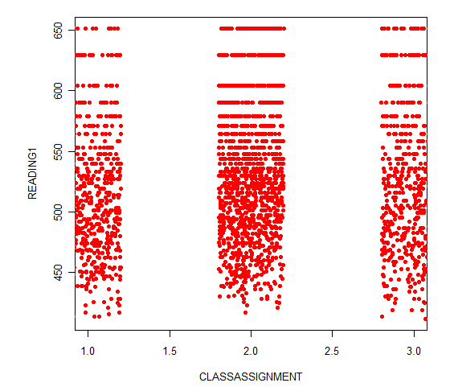

Post Hole 2—Use exploratory data analytic techniques to describe the distribution of a variable.

Explore READING1: (A checklist is good.)
*
Explore CLASSASSIGNMENT: (A checklist is good.)
*
READING1
mean sd 0% 25% 50% 75% 100% n NA
528.116 56.78715 412 485 524 571 651 2620 116
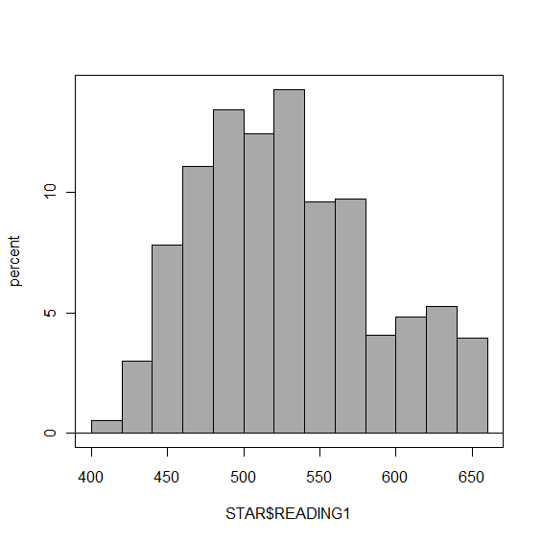 | 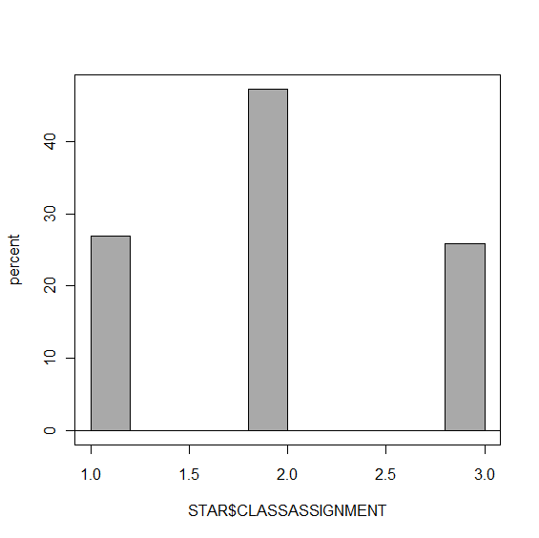

Post Hole 1—Use exploratory data analytic techniques to investigate the relationship between two variables.

Explore READING1 vs. CLASSASSIGNMENT: (A checklist is generally good, but interpret the magnitude with a careful sentence.)
(On the final, I will not ask you to do this for a polychotomous predictor, but it may be helpful to examine my attempt.)

Direction: This is tricky because it depends on your reference category!
Outliers: Positive outliers (perhaps due to a ceiling effect?)
Linearity: Necessarily (as long as we compare two categories at a time). It does not make sense to drop one line through all categories!
Magnitude: The average reading score for small class sizes is greatest (m = 536). The average for the regular class sizes is the least (m = 517), and the average for classes with aides is somewhere in the middle (m = 525). I’m not sure what those differences imply for the American Dream, but they may be huge. (I got the numbers from the regression output, but you can sort of see them, especially in the boxplots.)
Strength: Weak
*
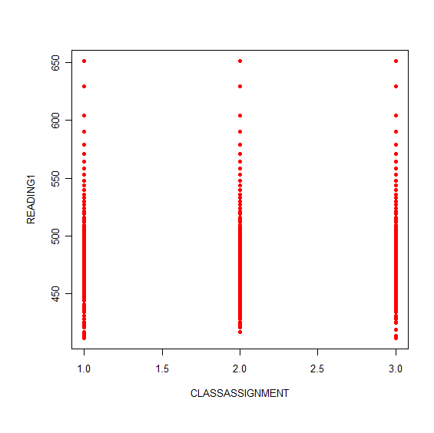 | 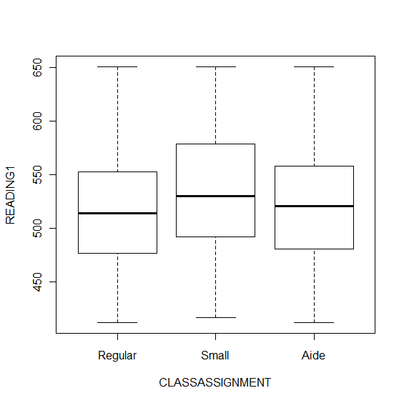

Post Hole 3—Conduct a z-score transformation by hand from a small data set.

READING1: 530 540 550 520 510 510 550 530 530 530

Please show your work:
*
Please note the mean of the raw distribution:
Please note the sum of squared mean deviations:
Please note the variance of the raw distribution:
Please note the standard deviation of the raw distribution:

