Tennessee's K-3 Class Size Study
Filename | star.sav
Overview | The Student/Teacher Achievement Ratio (STAR) was a four-year longitudinal class-size study funded by the Tennessee General Assembly and conducted by the State Department of Education. Over 7,000 students in 79 schools were randomly assigned into one of three interventions: small class (13 to 17 students per teacher), regular class (22 to 25 students per teacher), and regular-with-aide class (22 to 25 students with a full-time teacher's aide). Classroom teachers were also randomly assigned to the classes they would teach. The interventions were initiated as the students entered school in kindergarten and continued through third grade.
Source | http://www.heros-inc.org/star.htm
Sample size | 2620 students who were randomly assigned to regular classes, small classes or regular classes with aide during both kindergarten and first grade.

Theory: Small class sizes or teaching aides are conducive to learning because they provide students the one-on-one attention they need for optimized learning.

Research Question: In the population of Tennessee early elementary schoolers, does attending small classes in kindergarten and first grade improve first grade test scores? Does attending classed with a full-time teacher’s aide improve first grade test scores? (Note: we can ask, and answer, a causal question because students were randomized into either a small class, a regular class or a regular class with a full-time aide. Because of the randomization, the three groups begin equal in expectation. If they finish different, then that difference is reasonably attributable to the experimental condition.)

Outcome Variable:
READING1 | 1st grade reading scores | Continuous
Predictor Variable:
CLASSASSIGNMENT | 1 = the student was assigned to regular classes K-1  2 = the student was assigned to small classes K-1  3 = the student was assigned to aided classes K-1 | Polychotomous
Dummies:
SMALLK | 1 = the student was assigned to small classes K-1  0 = not | Dichotomous
AIDEK | 1 = the student was assigned to aided classes K-1  0 = not | Dichotomous

Post Hole 5—Interpret an R² statistic verbally and, using Boolean circles, graphically.
Post Hole 9—Interpret the parameter estimates and F-test from regressing a continuous variable on a set of dummy variables.
Post Hole 7—Interpret a confidence interval from a frequentist perspective and from a Bayesian perspective.
Post Hole 8—Evaluate the assumptions underlying a simple linear regression.
Interpret the R² statistic: (One careful sentence is good.)
CLASSASSIGNMENT predicts about 1.7% of the variation in READING1.  READING1 | CLASSASSIGNMENT
*
Interpret the parameter estimates and F-test: (Use the APA style.)
The null hypothesis for the omnibus F-test is that there is no relationship in the population between CLASSASSIGNMENT and READING1. Based on a p-value of less than .05, we reject the null hypothesis and conclude that there is a relationship in the population.

In our sample, the relationship between CLASSASSIGNMENT and READING1 is statistically significant, F(2, 2617) = 22.5, p < .001, partial η² =.017.

The mean for students who attend regular classes is 518.
The mean for students who attend small classes is 17 points greater than the mean for students who attend regular classes.
The mean for students who attend aided classes is 6 points greater than the mean for students who attend regular classes.

Yakkity yak yak yak, F(df_{between}, df_{within}) = xx.x, p = .xxx, partial η² =.xxx.
*
Interpret the confidence intervals: (Use both perspectives.)
The effect of small classes is an average improvement in reading scores. Confidence intervals provide a range of plausible values for the true average improvement in the population. The range is 12 to 22 points, but there is a 5% chance that this range misses the true average improvement. In the absence of further information, we are 95% confident that the true average improvement in the population is between 12 and 22 points.

The effect of aided classes is an average improvement in reading scores. Confidence intervals provide a range of plausible values for the true average improvement in the population. The range is 0.2 to 12.1 points, but there is a 5% chance that this range misses the true average improvement. In the absence of further information, we are 95% confident that the true average improvement in the population is between .02 and 12.1 points.
*
Evaluate the assumptions: (A checklist is good.)
Heteroskedasticity: Looks good. Equal variances.
Independence: Clustering within classes.
Normality: Not good. Bimodal distribution? Ceiling effect?
Linearity: Necessarily okay.
Outliers: There are high outliers in all three groups.
*

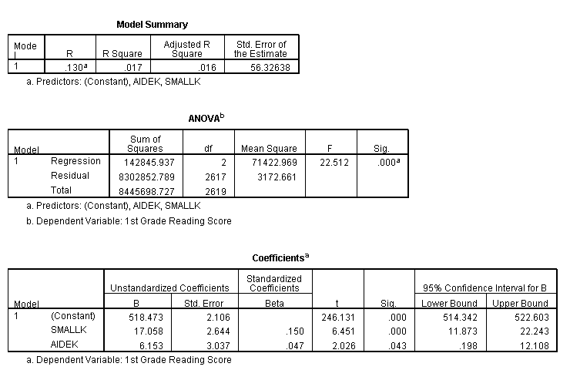
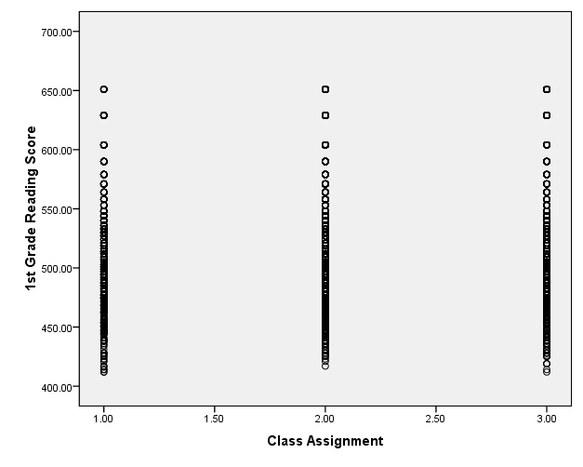

Post Hole 2—Use exploratory data analytic techniques to describe the distribution of a variable.

Explore READING1: (A checklist is good.)
Spread: Midspread = 86, Whiskers = 129, RLB = 356, RUB = 700. No outliers.
Location: Median = 524
Shape: Very strange. Perhaps bimodal. Things get very binny at the high end; this may be some sort of ceiling effect. It’s certainly not a typical ceiling effect with one sharp cut-off, but the binny cut-offs may be an artifact of IRT scaling in the face of a ceiling effect. I do wonder if reading is bimodal at early ages. You’ve got little readers who’ve been read to since the womb, and then you’ve got kids from families who are relying on schools to teach reading. Maybe? Anyhow, as long as you mention the strangeness, you’re fine as far as this class is concerned. You don’t need to know why it’s strange!
*
Explore CLASSASSIGNMENT: (A checklist is good.)
47.3% of students were assigned to small classes. 26.9% of students were assigned to regular classes. 25.8% of students were assigned to regular classes with full-time aides.
*
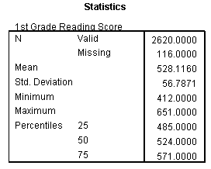 | 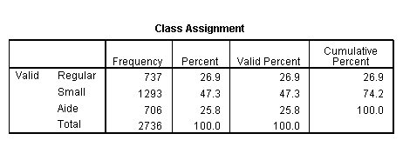
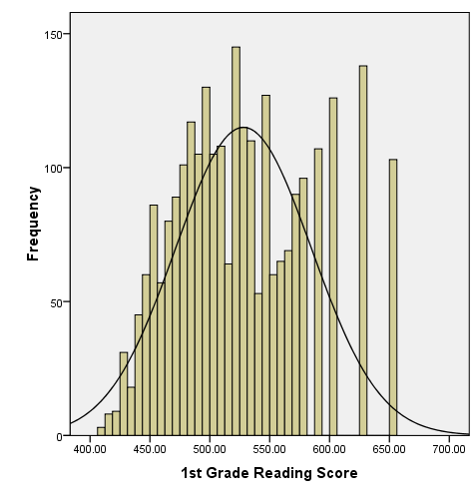 | 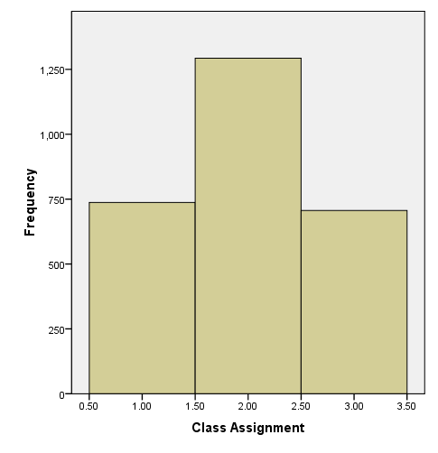

Post Hole 1—Use exploratory data analytic techniques to investigate the relationship between two variables.

Explore READING1 vs. CLASSASSIGNMENT: (A checklist is generally good, but interpret the magnitude with a careful sentence.)
(On the final, I will not ask you to do this for a polychotomous predictor, but it may be helpful to examine my attempt.)

Direction: This is tricky because it depends on your reference category!
Outliers: Positive outliers (perhaps due to a ceiling effect?)
Linearity: Necessarily (as long as we compare two categories at a time). It does not make sense to drop one line through all categories!
Magnitude: The average reading score for small class sizes is greatest (m = 536). The average for the regular class sizes is the least (m = 517), and the average for classes with aides is somewhere in the middle (m = 525). I’m not sure what those differences imply for the American Dream, but they may be huge. (I got the numbers from the regression output, but you can sort of see them, especially in the histograms.)
Strength: Weak
*
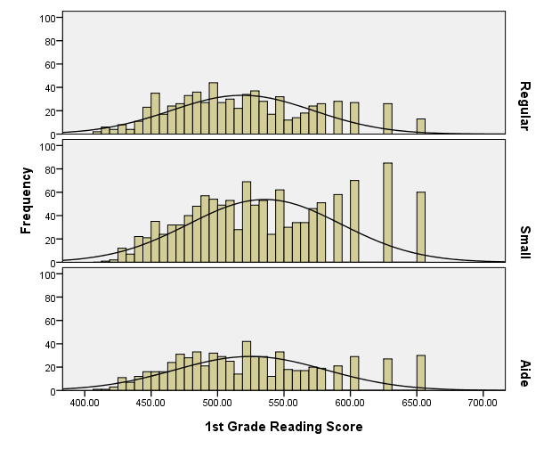

Post Hole 3—Conduct a z-score transformation by hand from a small data set.

READING1: 530 540 550 520 510 510 550 530 530 530

Please show your work:
raw | mean | mean dev. | sq. mean dev. | z
510 | 530 | -20 | 400 | -1.41421
510 | 530 | -20 | 400 | -1.41421
520 | 530 | -10 | 100 | -0.70711
530 | 530 | 0 | 0 | 0
530 | 530 | 0 | 0 | 0
530 | 530 | 0 | 0 | 0
530 | 530 | 0 | 0 | 0
540 | 530 | 10 | 100 | 0.707107
550 | 530 | 20 | 400 | 1.414213
550 | 530 | 20 | 400 | 1.414213

*
Please note the mean of the raw distribution: | 530
Please note the sum of squared mean deviations: | 1800
Please note the variance of the raw distribution: | 200
Please note the standard deviation of the raw distribution: | 14.14

