Tennessee's K-3 Class Size Study
Filename | star.sav
Overview | The Student/Teacher Achievement Ratio (STAR) was a four-year longitudinal class-size study funded by the Tennessee General Assembly and conducted by the State Department of Education. Over 7,000 students in 79 schools were randomly assigned into one of three interventions: small class (13 to 17 students per teacher), regular class (22 to 25 students per teacher), and regular-with-aide class (22 to 25 students with a full-time teacher's aide). Classroom teachers were also randomly assigned to the classes they would teach. The interventions were initiated as the students entered school in kindergarten and continued through third grade.
Source | http://www.heros-inc.org/star.htm
Sample size | 1585 students who were randomly assigned to regular classes (n = 344), small classes (n = 815) or regular classes with aides (n = 426) for kindergarten through 3rd grade.

Theory: Small class sizes or teaching aides are conducive to learning because they provide students the one-on-one attention they need for optimized learning.

Research Question: In the population of Tennessee early elementary schoolers, does attending small classes in kindergarten through third grade improve third grade math scores? Does attending classes with a full-time teacher’s aide improve third grade math scores? Are the effects the same for boys and girls? (Note: we can ask, and answer, a causal question because students were randomized into either a small class, a regular class or a regular class with a full-time aide. Because of the randomization, the three groups begin equal in expectation. If they finish different, then that difference is reasonably attributable to the experimental condition.)

Outcome Variable:
MATH3 | 3rd grade math scores | Continuous
Predictor Variables:
MALE | 0 = female  1 = male | Dichotomous
CLASSASSIGNMENT | 1 = the student was assigned to regular classes K-1  2 = the student was assigned to small classes K-1  3 = the student was assigned to aided classes K-1 | Polychotomous
Dummies for CLASSASSIGNMENT:
SMALLK | 1 = the student was assigned to small classes K-1  0 = not | Dichotomous
AIDEK | 1 = the student was assigned to aided classes K-1  0 = not | Dichotomous

For this posthole assessment, please use an alpha level of .10 instead of .05. This happens to make the results more pedagogically interesting.

Post Hole 10—Interpret a two-way analysis of variance using F-tests and graphs.

Interpret the two-way ANOVA: (Fully interpret at least one F-test,
using the APA style. Mention the F-tests that you do not fully interpret.)
Please use an alpha level of .10 instead of .05.

The null hypothesis for the omnibus F-test is that there is no relationship in the population between MATH3 and combined CLASSASSIGNMENT, MALE and their interaction. Based on a p-value of .012, we reject the null and conclude that there is a relationship in the population.
F(5, 1579) = 2.9, p = .012, partial η² =.009.

The null hypothesis for the F-test of the main effect of CLASSASSIGNMENT is that there is no relationship in the population between MATH3 and CLASSASSIGNMENT. Based on a p-value of .017, we reject the null and conclude that there is a relationship in the population.
F(2, 1579) = 4.1, p = .012, partial η² =.005.

The null hypothesis for the F-test of the main effect of MALE is that there is no relationship in the population between MATH3 and MALE. Based on a p-value of .553, we do not reject the null, and we do not conclude that there is a relationship in the population.
F(1, 1579) = 0.4, p = .553, partial η² =.000.

The null hypothesis for the F-test of the interaction between CLASSASSIGNMENT and MALE is that there is no interaction in the population between CLASSASSIGNMENT and MALE in the prediction of MATH3. Based on a p-value of .097, which is less than our alpha level of .10, we reject the null, and we conclude that there is an interaction in the population.
F(2, 1579) = 2.3, p = .097, partial η² =.003.

It appears that small classes and aided classes have little to no effect for girls, but for boys, small classes have a relatively large effect, and aided classes have a moderate effect.

Yakkity yak yak yak, F(df_{between}, df_{within}) = xx.x, p = .xxx, partial η² =.xxx.
*
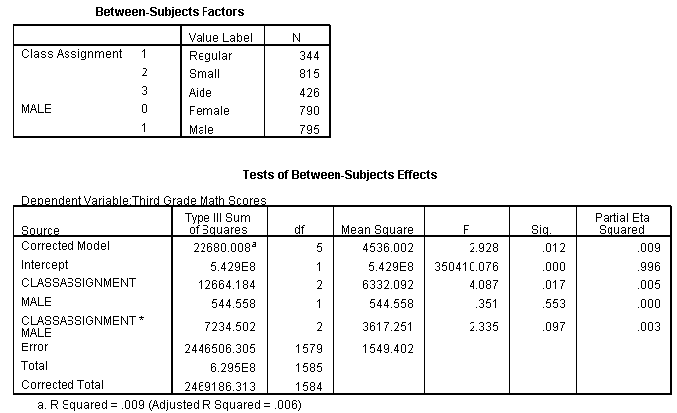
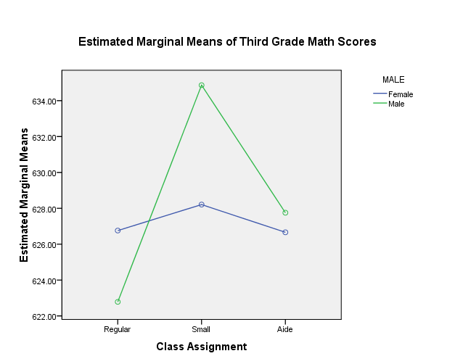

Post Hole 5—Interpret an R² statistic verbally and, using Boolean circles, graphically.
Post Hole 9—Interpret the parameter estimates and F-test from regressing a continuous variable on a set of dummy variables.
Post Hole 7—Interpret a confidence interval from a frequentist perspective and from a Bayesian perspective.
Post Hole 8—Evaluate the assumptions underlying a simple linear regression.
Interpret the R² statistic: (One careful sentence is good.)
CLASSASSIGNMENT predicts about 0.5% of the variation in MATH3.  MATH3 | CLASSASSIGNMENT
*
Interpret the parameter estimates and F-test: (Use the APA style.)
The null hypothesis for the omnibus F-test is that there is no relationship in the population between CLASSASSIGNMENT and MATH3. Based on a p-value of less than .05, we reject the null hypothesis and conclude that there is a relationship in the population.

In our sample, the relationship between CLASSASSIGNMENT and MATH3 is statistically significant, F(2, 1582) = 3.923, p = .020, partial η² =.005.

The mean for students who attend regular classes is 625.0.
The mean for students who attend small classes is 6.6 points greater than the mean for students who attend regular classes.
The mean for students who attend aided classes is 2.3 points greater than the mean for students who attend regular classes.

Yakkity yak yak yak, F(df_{between}, df_{within}) = xx.x, p = .xxx, partial η² =.xxx.
*
Interpret the confidence intervals: (Use both perspectives.)
The effect of small classes is an average improvement in reading scores. Confidence intervals provide a range of plausible values for the true average improvement in the population. The range is 1.6 to 11.5 points, but there is a 5% chance that this range misses the true average improvement. In the absence of further information, we are 95% confident that the true average improvement in the population is between 1.6 and 11.5 points.

The effect of aided classes is inconclusive. Confidence intervals provide a range of plausible values for the true average in the population. The range is -3.3 to 7.9 points, but there is a 5% chance that this range misses the true average improvement. In the absence of further information, we are 95% confident that the true average improvement in the population is between -3.3 to 7.9 points. Because this range straddles zero, we cannot conclude there is any effect of the intervention.
*
Evaluate the assumptions: (A checklist is good.)
Heteroskedasticity: Looks good. Equal variances.
Independence: Clustering within classes.
Normality: Not bad.
Linearity: Necessarily okay.
Outliers: There are high outliers in all three groups, especially classes with aides.
*

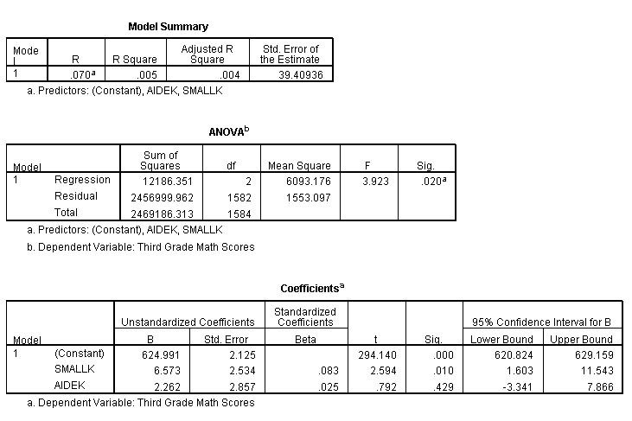
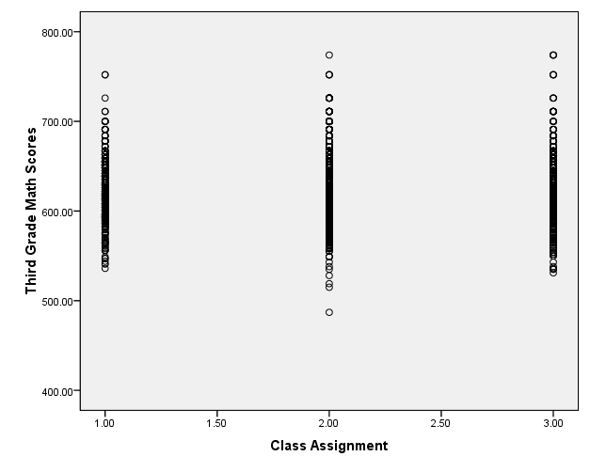 | 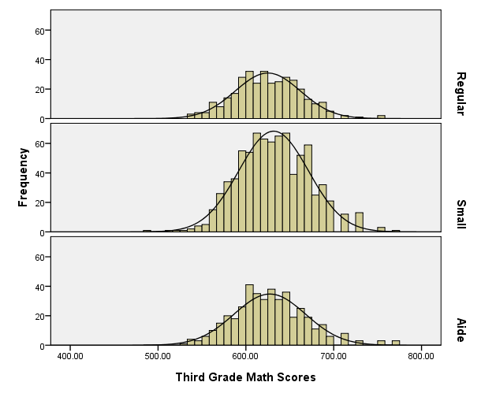

Post Hole 2—Use exploratory data analytic techniques to describe the distribution of a variable.

Explore MATH3: (A checklist is good.)
Spread: Midspread = 54, Whiskers = 81, RLB = 520, RUB = 736. There are some upper and lower outlier but nothing too extreme, with a minimum of 487 and a maximum of 774.
Location: Median = 629
Shape: Approximately normal. (There are strange bins in the upper tail; I think this is a weird artifact of IRT scaling.)
*
Explore CLASSASSIGNMENT: (A checklist is good.)
51.5% of students were assigned to small classes. 22.0% of students were assigned to regular classes. 26.6% of students were assigned to regular classes with full-time aides.
*
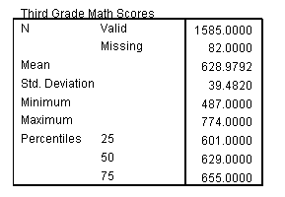 | 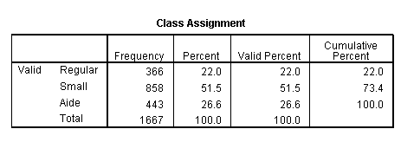
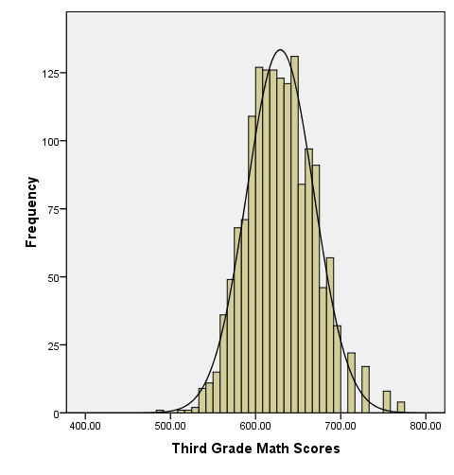 | 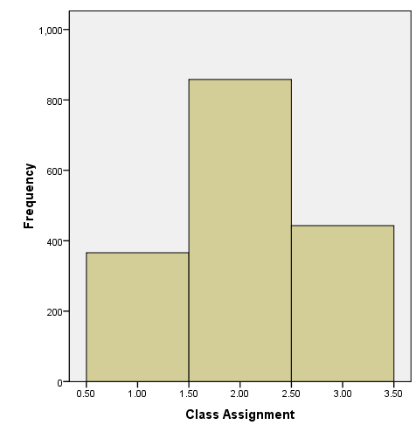

Post Hole 1—Use exploratory data analytic techniques to investigate the relationship between two variables.

Explore MATH3 vs. CLASSASSIGNMENT: (A checklist is generally good, but interpret the magnitude with a careful sentence.)
(On the final, I will not ask you to do this for a polychotomous predictor, but it may be helpful to examine my attempt.)

Direction: This is tricky because it depends on your reference category!
Outliers: Positive outliers (perhaps due to a ceiling effect?)
Linearity: Necessarily (as long as we compare two categories at a time). It does not make sense to drop one line through all categories!
Magnitude: The average math core for small class sizes is greatest (m = 632). The average for the regular class sizes is the least (m = 625), and the average for classes with aides is somewhere in the middle (m = 627). I’m not sure what those differences imply for the American Dream, but they may be huge. (I got the numbers from the regression output, but you can sort of see them, especially in the histograms.)
Strength: Weak
*

Post Hole 3—Conduct a z-score transformation by hand from a small data set.

MALE: 0 0 0 0 1 1 1 1 1 1

Please show your work:
raw | mean | mean dev. | sq. mean dev. | z
0 | 0.6 | -0.6 | 0.36 | -1.16189
0 | 0.6 | -0.6 | 0.36 | -1.16189
0 | 0.6 | -0.6 | 0.36 | -1.16189
0 | 0.6 | -0.6 | 0.36 | -1.16189
1 | 0.6 | 0.4 | 0.16 | 0.774596
1 | 0.6 | 0.4 | 0.16 | 0.774596
1 | 0.6 | 0.4 | 0.16 | 0.774596
1 | 0.6 | 0.4 | 0.16 | 0.774596
1 | 0.6 | 0.4 | 0.16 | 0.774596
1 | 0.6 | 0.4 | 0.16 | 0.774596

*
Please note the mean of the raw distribution: | 0.6
Please note the sum of squared mean deviations: | 2.4
Please note the variance of the raw distribution: | 0.267
Please note the standard deviation of the raw distribution: | 0.516

