Data Set: This data set comes from a study on child life specialists. When the 4-year old in your life needs surgery, the child life specialist is the nice person in the hospital who sits down with your child and a teddy bear and explains that the teddy bear is sick, but he’s going to breath into the mask and go to sleep, and when he wakes up…

Theory 1: Interventions by child life specialist help children make meaning out of their situation and consequently decreases their anxiety (for example as they undergo anesthesia induction).

Research Question 1: For children 8 years or younger, does child life intervention decrease anxiety during anesthesia induction? (Notice the causal question. This is a true experiment with a control group, so a causal conclusion is warranted).

Outcome: Induction_Anxiety, ranges 0 – 8, a measure composited from a checklist that checks whether the child is crying, turning away, verbally refusing, verbalizing fear, pushing away, covering face, hysterically crying and/or kicking and flailing. E.g., a child who exhibits all eight of the behaviors during the anesthesia induction gets an 8.

Question Predictor: Intervention, 1 = received child life intervention, 0 = did not

Post Hole 2—Use exploratory data analytic techniques to describe the distribution of a variable.

Explore Induction_Anxiety: (A checklist is good.)
*
Explore Intervention: (A checklist is good.)
*

Statistics
 |  | Induction_Anxiety | Intervention
N | Valid | 72 | 72
N | Missing | 2 | 2
Mean |  | 1.6944 | .56
Std. Deviation |  | 2.26821 | .500
Minimum |  | .00 | 0
Maximum |  | 8.00 | 1
Percentiles | 25 | .0000 | .00
Percentiles | 50 | 1.0000 | 1.00
Percentiles | 75 | 2.0000 | 1.00

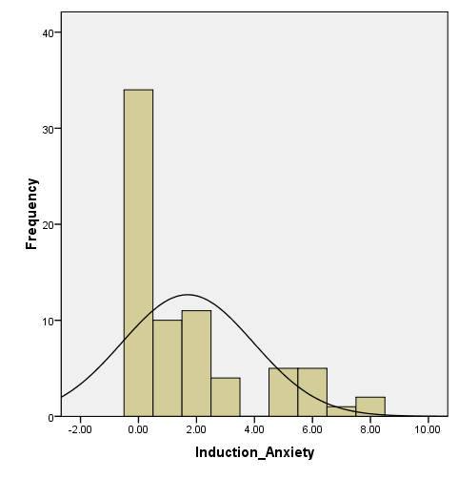 | 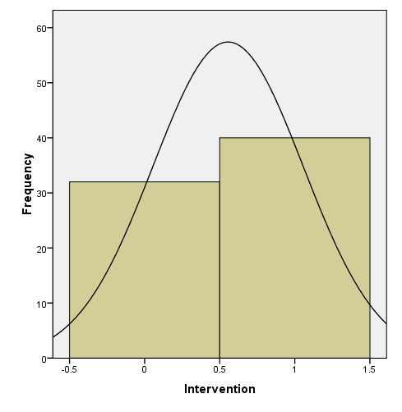

Post Hole 1—Use exploratory data analytic techniques to investigate the relationship between two variables.

Explore Induction_Anxiety vs. Intervention: (A checklist is generally good, but interpret the magnitude with a careful sentence.)
*
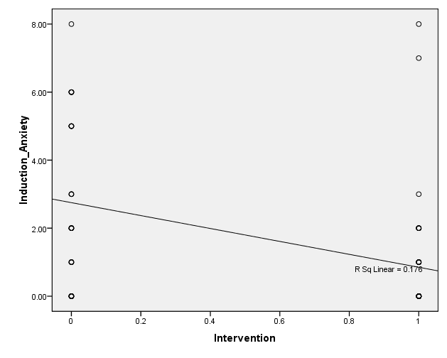
Regression Output Below
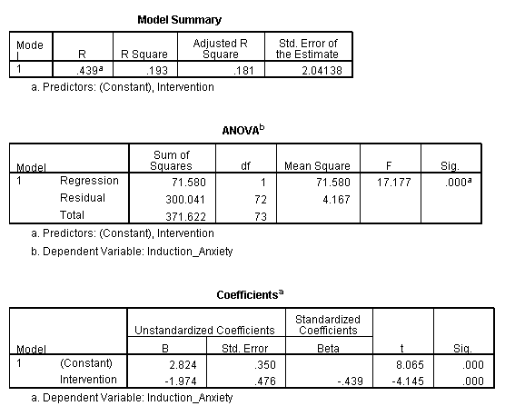

Post Hole 11—Note the threats to validity posed by measurement error in the outcome and predictor(s) of a model.

Model: $\text{Induction_Anxiety}=β_{0}+β_{1}\text{Intervention}+ε$
Note the threats to validity posed by measurement error:
*

