Post Holes 6 7 8 12 Save As “Your_Name_Final.doc”

Theory: In some states, most eligible students take the SATs, but in other states only a few eligible students take the SATs. Which states have a higher average SAT score? Because only the best of the best students take the SAT in some states, states with proportionally few participants will tend to score higher on the SAT.
Our sample is the United States (n = 50). Notice that I described the 50 states as a “sample,” not the “population.”
Research Question: Are TOTAL and PERCENT negatively correlated?
Outcome: TOTAL, average total SAT score for each state
Predictor: PERCENT, percentage of eligible students who took the SAT

Post Hole 6—State the null hypothesis of a test for statistical significance; reject (or not) the null hypothesis; draw an inference (or not) from a sample to a population.
Post Hole 7—Interpret a confidence interval from a frequentist perspective and from a Bayesian perspective.
Post Hole 8—Evaluate the assumptions underlying a simple linear regression.

Test for statistical significance:
*
Interpret the confidence interval: (Use both perspectives.)
*
Evaluate the assumptions: (A checklist is good.)
*
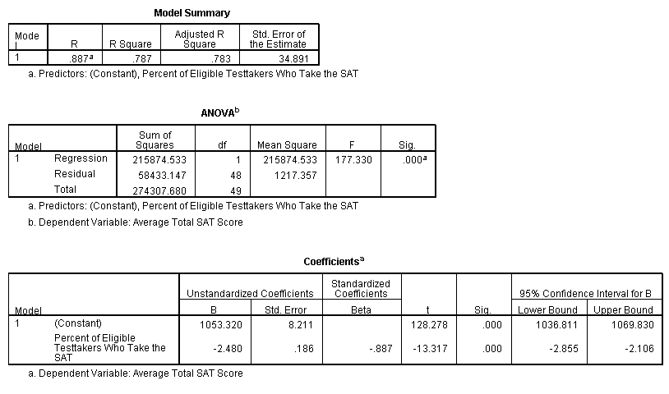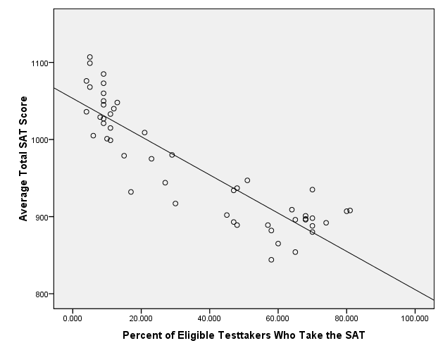

Post Hole 12—Check your GLM assumptions by interpreting a residual-versus-fitted (RVF) plot, a histogram of residuals, a normal probability plot, residual statistics, leverage statistics, and influence statistics.

Check your GLM assumptions:

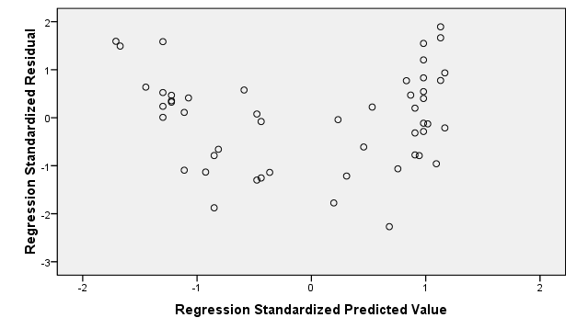

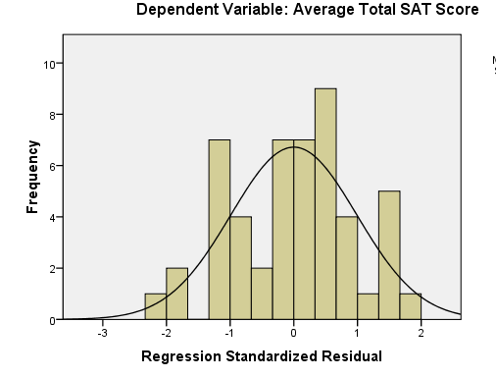 | 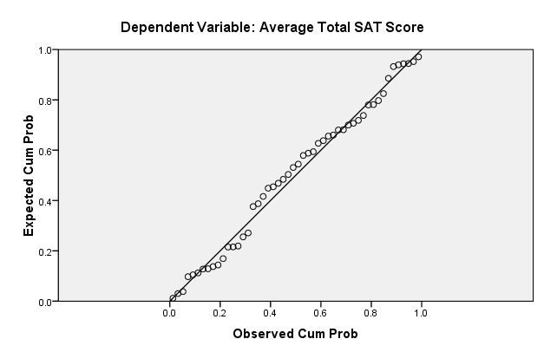
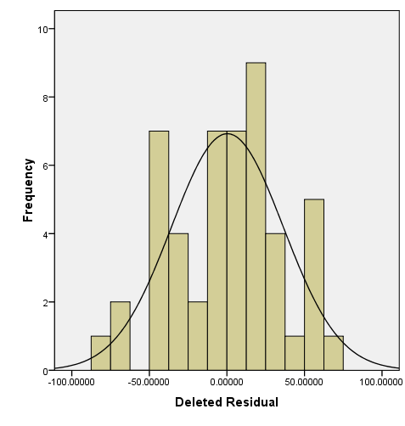
  Extreme Values
   |  |  | Case Number | Value
  Deleted Residual | Highest | 1 | 37 | 69.27074
  Deleted Residual | Highest | 2 | 23 | 60.88450
  Deleted Residual | Highest | 3 | 1 | 60.38187
  Deleted Residual | Highest | 4 | 4 | 58.47244
  Deleted Residual | Highest | 5 | 3 | 56.44230
  Deleted Residual | Lowest | 1 | 48 | -81.56232
  Deleted Residual | Lowest | 2 | 41 | -67.82965
  Deleted Residual | Lowest | 3 | 34 | -63.23004
  Deleted Residual | Lowest | 4 | 17 | -46.41701
  Deleted Residual | Lowest | 5 | 44 | -44.82666
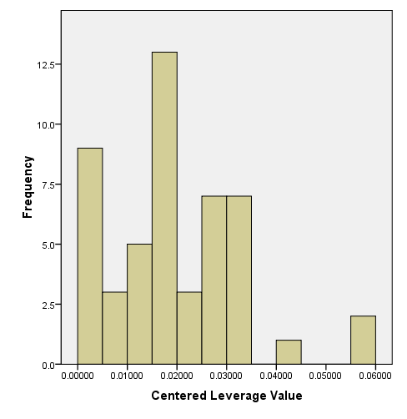
  Extreme Values
   |  |  | Case Number | Value
  Centered  Leverage  Value | Highest | 1 | 1 | .05967
  Centered  Leverage  Value | Highest | 2 | 3 | .05709
  Centered  Leverage  Value | Highest | 3 | 6 | .04281
  Centered  Leverage  Value | Highest | 4 | 4 | .03443
  Centered  Leverage  Value | Highest | 5 | 5 | .03443ª
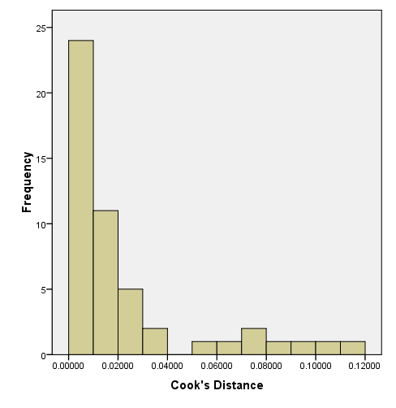
  Extreme Values
   |  |  | Case Number | Value
  Cook's Distance | Highest | 1 | 1 | .11930
  Cook's Distance | Highest | 2 | 3 | .10086
  Cook's Distance | Highest | 3 | 37 | .09077
  Cook's Distance | Highest | 4 | 48 | .08055
  Cook's Distance | Highest | 5 | 4 | .07643
  Cook's Distance | Lowest | 1 | 7 | .00000

