Postholes 3 13 Save As “Your_Name_Final.doc”

Post Hole 13—Propose a non-linear transformation, if necessary, to meet the normality and linearity assumptions of the general linear model.
What non-linear transformation might you try if your outcome looked like this?:
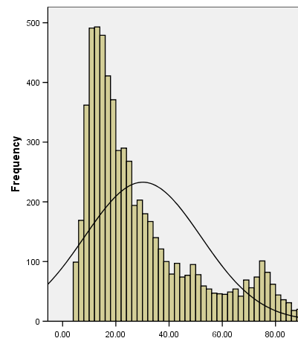 | Go down Tukey’s ladder to pull in the long upper tail. I might try a log transformation. I would use the natural log because the variable is my outcome.

What non-linear transformation(s) might you try if a bivariate scatterplot of your outcome vs. predictor looked like the following?:
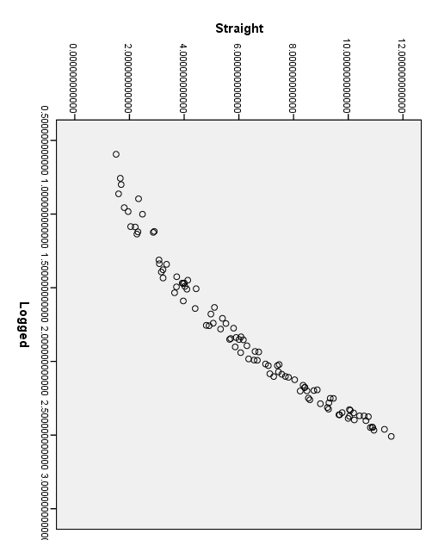 | I would go down in X or down in Y. I would start with X because transforming the predictor is “less expensive.” I would start with a log, and I would use base-2 because it’s the predictor, and I could talk about the difference in Y associated with a doubling of X.

Post Hole 3—Conduct a z-score transformation by hand from a small data set.

Reading Scores: 50 50 80 80 90 90 90 90 90 90

Please show your work:
RAW | MEAN | MEAN DEVIATION | SQ MEAN DEVIATION | Z-SCORE
50 | 80 | -30 | 900 | -1.83712
50 | 80 | -30 | 900 | -1.83712
80 | 80 | 0 | 0 | 0
80 | 80 | 0 | 0 | 0
90 | 80 | 10 | 100 | 0.612372
90 | 80 | 10 | 100 | 0.612372
90 | 80 | 10 | 100 | 0.612372
90 | 80 | 10 | 100 | 0.612372
90 | 80 | 10 | 100 | 0.612372
90 | 80 | 10 | 100 | 0.612372

*
Please note the mean of the raw distribution: | 80
Please note the sum of squared mean deviations: | 2400
Please note the variance of the raw distribution: | 266.7
Please note the standard deviation of the raw distribution: | 16.3

