Post Holes 6 8 13 14 Save As “Your_Name.doc”

Data Set: In Los Angeles (circa 1980), interviewers from the Institute for Social Science Research at UCLA surveyed a multiethnic sample of 256 community members for an epidemiological study of depression and help-seeking behavior among adults (Afifi and Clark 1984).

Theory: Depression impairs work activity and, consequently, income.

Research Question: In the population of Los Angelinos, is there a negative relationship between income and depression, such that greater depression is associated with lower income?

Outcome: LNINCOME, natural log of income
Question Predictor: DEPRESSION, a score on the CESD depression index

Back Story: Surfing the web, I found the following RVF plot as a paradigmatic example of heteroskedasticity:

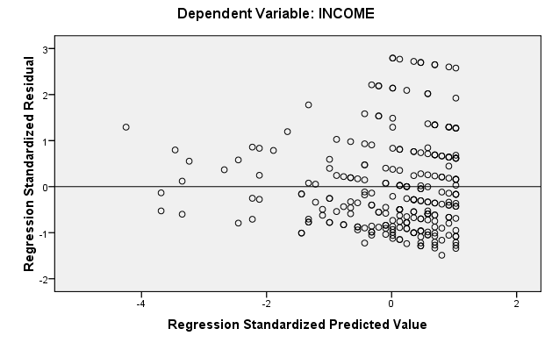

However, it looked to me like there was a normality problem that perhaps could be cleared up with a transformation of the outcome, INCOME. In this post hole, I transformed the outcome, and you can judge whether or not the transformed relationship is still heteroskedastic.

Post Hole 6—State the null hypothesis of a test for statistical significance; reject (or not) the null hypothesis; draw an inference (or not) from a sample to a population.
Post Hole 8—Evaluate the assumptions underlying a simple linear regression.

Test for statistical significance:
*
Evaluate the assumptions: (A checklist is good.)
*

Model Summary^{b}
Model | R | R Square | Adjusted R Square | Std. Error of the Estimate
1 | .247ª | .061 | .057 | .75951
a. Predictors: (Constant), DEPRESSION
b. Dependent Variable: LNINCOME

ANOVA^{b}
Model |  | Sum of Squares | df | Mean Square | F | Sig.
1 | Regression | 9.519 | 1 | 9.519 | 16.502 | .000ª
1 | Residual | 146.521 | 254 | .577
1 | Total | 156.040 | 255
a. Predictors: (Constant), DEPRESSION
b. Dependent Variable: LNINCOME

Coefficientsª
Model |  | Unstandardized Coefficients |  | Standardized Coefficients | t | Sig. | 95% Confidence Interval for B
 |  | B | Std. Error | Beta | t | Sig. | Lower Bound | Upper Bound
1 | (Constant) | 3.029 | .068 |  | 44.461 | .000 | 2.895 | 3.164
1 | DEPRESSION | -.022 | .005 | -.247 | -4.062 | .000 | -.032 | -.011
a. Dependent Variable: LNINCOME

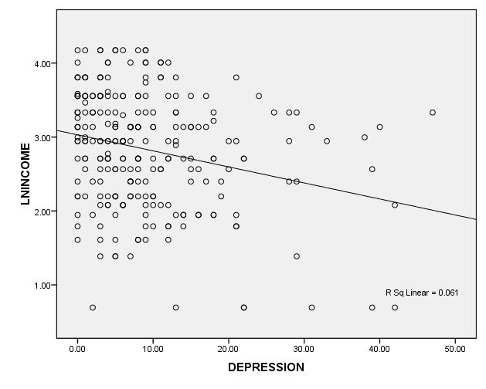

Post Hole 13—Propose a non-linear transformation, if necessary, to meet the normality and linearity assumptions of the general linear model.

What non-linear transformation might you try if INCOME were your outcome?:
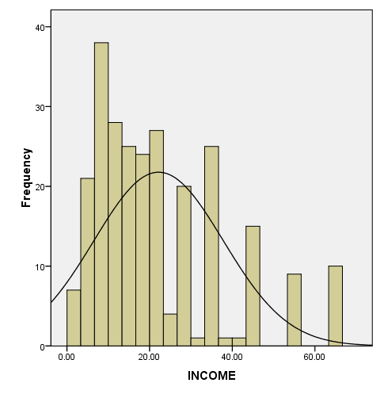

Post Hole 14—Judge whether robust standard errors are necessary for estimation.

Make the call regarding robust standard errors based on the following RVF plot:
*
