Post Holes 6 8 13 14 Save As “Your_Name.doc”

Data Set: In Los Angeles (circa 1980), interviewers from the Institute for Social Science Research at UCLA surveyed a multiethnic sample of 256 community members for an epidemiological study of depression and help-seeking behavior among adults (Afifi and Clark 1984).

Theory: Depression impairs work activity and, consequently, income.

Research Question: In the population of Los Angelinos, is there a negative relationship between income and depression, such that greater depression is associated with lower income?

Outcome: LNINCOME, natural log of income
Question Predictor: DEPRESSION, a score on the CESD depression index

Back Story: Surfing the web, I found the following RVF plot as a paradigmatic example of heteroskedasticity:

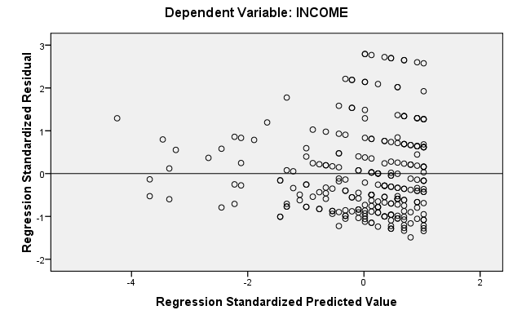

However, it looked to me like there was a normality problem that perhaps could be cleared up with a transformation of the outcome, INCOME. In this post hole, I transformed the outcome, and you can judge whether or not the transformed relationship is still heteroskedastic.

Post Hole 6—State the null hypothesis of a test for statistical significance; reject (or not) the null hypothesis; draw an inference (or not) from a sample to a population.
Post Hole 8—Evaluate the assumptions underlying a simple linear regression.

Test for statistical significance:
The null hypothesis is that there is no relationship between LNINCOME and DEPRESSION in the population. If the null hypothesis were true, it would be very unlikely to observe a relationship as large (or larger) as the one in our sample, t(256) = -4.06, p < .001). Therefore, we reject the null, and conclude that there is a relationship in the population.
*
Evaluate the assumptions: (A checklist is good.)
Homoskedasticity-no problem; small sample sizes in hi DEPRESSION make it look like a funnel
Independence-can’t tell; maybe clustering in neighborhoods
Normality-okay
Linearity-okay
Outliers- Bottom incomes look weird. Lo INCOME and hi DEPRESSION very influential, making the relationship too negative.
*

Model Summary^{b}
Model | R | R Square | Adjusted R Square | Std. Error of the Estimate
1 | .247ª | .061 | .057 | .75951
a. Predictors: (Constant), DEPRESSION
b. Dependent Variable: LNINCOME

ANOVA^{b}
Model |  | Sum of Squares | df | Mean Square | F | Sig.
1 | Regression | 9.519 | 1 | 9.519 | 16.502 | .000ª
1 | Residual | 146.521 | 254 | .577
1 | Total | 156.040 | 255
a. Predictors: (Constant), DEPRESSION
b. Dependent Variable: LNINCOME

Coefficientsª
Model |  | Unstandardized Coefficients |  | Standardized Coefficients | t | Sig. | 95% Confidence Interval for B
 |  | B | Std. Error | Beta | t | Sig. | Lower Bound | Upper Bound
1 | (Constant) | 3.029 | .068 |  | 44.461 | .000 | 2.895 | 3.164
1 | DEPRESSION | -.022 | .005 | -.247 | -4.062 | .000 | -.032 | -.011
a. Dependent Variable: LNINCOME

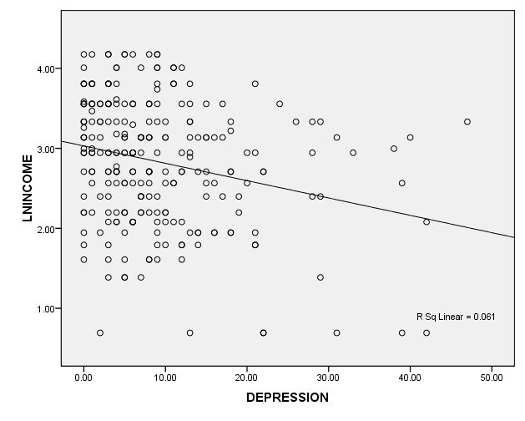

Post Hole 13—Propose a non-linear transformation, if necessary, to meet the normality and linearity assumptions of the general linear model.

What non-linear transformation might you try if INCOME were your outcome?:
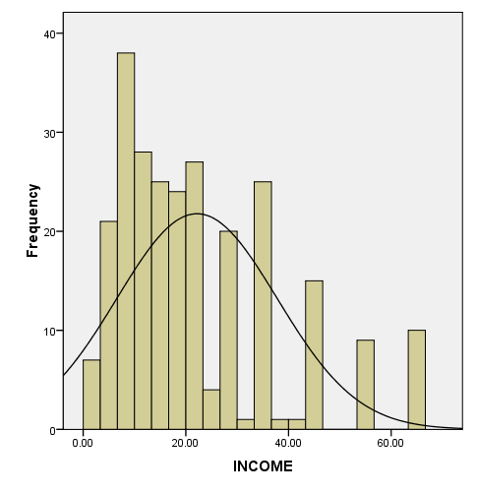 | Go down to pull in long lower tail. Try log transformation. (Also, notice the ceiling effect! Unfortunately, there is no transformation that will help us distinguish those identical scores. Which want to break through the ceiling? Which are just about right? Who knows? “We cannot fix through analysis what we bungled through design,” John Willett. Also, notice that we are transforming to achieve residual normality, not necessarily linearity.)

Post Hole 14—Judge whether robust standard errors are necessary for estimation.

Make the call regarding robust standard errors based on the following RVF plot:
No. Deal with the outliers, and things will look good.
*
