Post Holes 4 15 Save As “Your_Name.doc”

Data Set: 1621 colleges and universities. Scott, M, Bailey, T, & Kienzl, G (2006). Relative success: Determinants of college graduation rates in public and private colleges in the US, Research in Higher Education, 47(1)

Theory: Since financial aid allows students to focus more on academics over after-school jobs, schools that give more financial aid will tend to have higher graduation rates.

Research Question: In the population of U.S. colleges and universities, is graduation positively correlated with financial aid, controlling for school attributes such as public/private status and average SAT scores?

Outcome: PctGrad, graduation rate, percent of students who graduate in 6 years
Question Predictor: FinAid, average financial aid award in 1000s of dollars
Control Predictors:
Public, a dummy variable for whether the school is public (= 1) or private (= 0)
SATMidSpread, the difference between the 75th percentile and 25th percentile
indicating the spread of SAT scores within the school
SAT75thPercentile, within the school, the SAT score of the students with a
percentile rank of 75

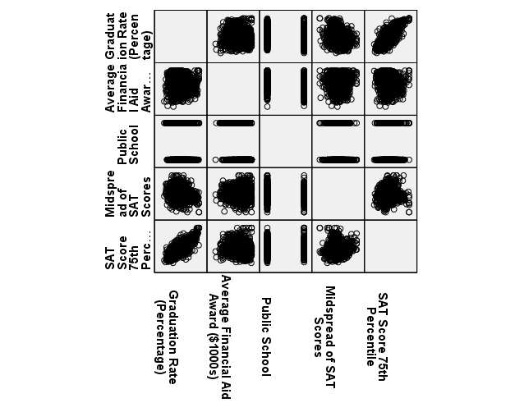
Post Hole 4—Interpret a correlation matrix.

Interpret the correlation matrix :
Only our question predictor, financial aid, is uncorrelated with our outcome, graduation rate (r = .028, p = .258). Public schools tend to have lower graduation rates than private schools (r = -.240), and schools with wider ranges of academic ability (as measured by the SAT) tend to have lower graduation rates. The strongest predictor of graduation rate, however, is the 75th percentile of the SAT, where schools with students of higher academic ability tend to graduate more of those students—no surprise.

The correlations among the predictors are all small to negligible, except the negative correlation between financial aid and public schools (r = -.450).
*

Post Hole 15—Interpret a correlation matrix and/or partial correlation matrix and note what they may foreshadow about multiple regression.

Interpret the partial correlation matrix: (Carefully interpret the correlation between the question predictor and outcome. Be brief with the other correlations.)
Controlling for SAT scores, financial aid has a small, but statistically significant, positive relationship with graduation rate (partial-r = .127, p < .001).

All the other partial correlations are about the same as their respective simple correlations, except one: controlling for SAT scores, the negative partial correlation between SAT range and graduate rate is greater than the simple correlation (from r = -.266 to partial r = -.409).
*
What do the correlations foreshadow about multiple regression?:
First, it will be important to have SAT75thPercentile in our model as a control predictor, because it is such a strong predictor of GradPCT. Any nuanced analysis of GradPCT will need to “look beyond” academic ability.

Controlling for SAT75thPercentile, SATMidspread has a relatively strong partial correlation with GradPCT but a relatively weak correlation with FinAid. This suggests that the variation that SATMidspread predicts in GradPCT is unique from the variation that FinAid predicts in GradPCT. So, if we further control for SATMidspread, the partial correlation between GradPCT and FinAid should increase.
*
