Postholes 9 16 Save As “Your_Name_Final.doc”

Data Set: 887 Adolescents

Source: Brown, JD, L’Engle, KL, Pardun, CJ, Guo, G, Kenneavy, K, & Jackson, C (2006). Sexy media matter: Exposure to sexual content in music movies, television, and magazines predictors Black and White Adolescents’ Sexual Behavior, Pediatrics, 117(4), 1018-1027 (by way of Judith Singer)

Theory: In the public debates on how to curb teenage sexual engagement, the societal forces that influence sexual engagement (such as school, family and religious values) take center stage; however, in addition to societal forces, biological forces are at play.

Research Question 1: In the population, is there a negative relationship between puberty onset and sexual engagement such that earlier puberty onset is associated with greater sexual engagement?

Research Question 2: Does the relationship persist when we control for the demographic variables of age and gender and the societal-influence variables of school, family and religion?

Variables:
Outcome—Sexual Activity (Activity) A continuous measure of the adolescent’s sexual activity based on a confidential self-report

Question Predictor—Puberty Onset (Puberty) A polychotomous variable where
1 = late onset puberty, 2 = average onset puberty and 3 = early onset puberty
The corresponding dummy variables are:
LatePuberty, 1 = late onset puberty, 0 = not
EarlyPuberty, 1 = early onset puberty, 0 = not
Note that average onset puberty (Puberty = 2) is our reference category

Control Predictors—
Age (Age) Adolescent’s age in years
Gender (Male) Adolescent’s gender, Female = 0, Male = 1
School Engagement (School) Adolescent’s report of school engagement
Family Engagement (Family) Adolescent’s report of family engagement
Religious Engagement (Religion) Adolescent’s report of religious engagement

Post Hole 9—Interpret the parameter estimates and F-test from regressing a continuous variable on a set of dummy variables.

Interpret the parameter estimates and F-test: (Use the APA style.)
F(df_{between}, df_{within}) = #, p = #, partial η² = #.

We need to do some translation from ANOVA language to regression language and back again. This is all terminological, not conceptual:

The partial η² in this case is just R². In general, the partial η² for a predictor is the R² change when we add the predictor to the model last in a tightly nested hierarchy of models. The key here is that the set of dummies is conceptually one predictor

df_{between} is the same thing as df_{regression}

df_{within} is the same thing as df_{residual}
*

Model Summary^{b}
Model | R | R Square | Adjusted R Square | Std. Error of the Estimate
1 | .183ª | .034 | .031 | 1.77306

ANOVA^{b}
Model |  | Sum of Squares | df | Mean Square | F | Sig.
1 | Regression | 96.371 | 2 | 48.185 | 15.327 | .000ª
1 | Residual | 2779.075 | 884 | 3.144
1 | Total | 2875.446 | 886
a. Predictors: (Constant), EarlyPuberty, LatePuberty
b. Dependent Variable: Activity

Coefficientsª
Model |  | Unstandardized Coefficients |  | Standardized Coefficients | t | Sig. | 95% Confidence Interval for B
 |  | B | Std. Error | Beta | t | Sig. | Lower Bound | Upper Bound
1 | (Constant) | 4.313 | .064 |  | 67.282 | .000 | 4.187 | 4.439
1 | LatePuberty | -.875 | .245 | -.118 | -3.564 | .000 | -1.357 | -.393
1 | EarlyPuberty | .901 | .227 | .131 | 3.963 | .000 | .455 | 1.348
a. Dependent Variable: Activity

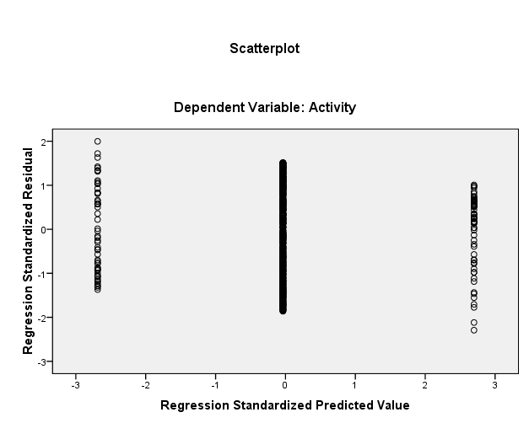

Post Hole 16—Interpret a fitted multiple regression model.

Interpret the fitted multiple regression model: (Carefully interpret the regression coefficient(s) associated with the question predictor(s). Be very brief with the control predictors.)
*

Model Summary^{b}
Model | R | R Square | Adjusted R Square | Std. Error of the Estimate
1 | .333ª | .111 | .104 | 1.70547

ANOVA^{b}
Model |  | Sum of Squares | df | Mean Square | F | Sig.
1 | Regression | 318.749 | 7 | 45.536 | 15.655 | .000ª
1 | Residual | 2556.697 | 879 | 2.909
1 | Total | 2875.446 | 886
a. Predictors: (Constant), Religion, Age, EarlyPuberty, LatePuberty, Male, School, Family
b. Dependent Variable: Activity

Coefficientsª
Model |  | Unstandardized Coefficients |  | Standardized Coefficients | t | Sig. | 95% Confidence Interval for B
 |  | B | Std. Error | Beta | t | Sig. | Lower Bound | Upper Bound
1 | (Constant) | .258 | 1.333 |  | .194 | .846 | -2.357 | 2.874
1 | LatePuberty | -.801 | .239 | -.108 | -3.357 | .001 | -1.270 | -.333
1 | EarlyPuberty | .639 | .222 | .093 | 2.877 | .004 | .203 | 1.075
1 | Age | .297 | .084 | .115 | 3.548 | .000 | .133 | .461
1 | Male | -.164 | .121 | -.046 | -1.363 | .173 | -.401 | .072
1 | School | -.301 | .078 | -.128 | -3.856 | .000 | -.455 | -.148
1 | Family | -.709 | .140 | -.177 | -5.078 | .000 | -.983 | -.435
1 | Religion | .042 | .066 | .021 | .645 | .519 | -.087 | .172
a. Dependent Variable: Activity

