Postholes 10 17 Save As “Your_Name_Final.doc”

Data Set: 887 Adolescents

Source: Brown, JD, L’Engle, KL, Pardun, CJ, Guo, G, Kenneavy, K, & Jackson, C (2006). Sexy media matter: Exposure to sexual content in music movies, television, and magazines predictors Black and White Adolescents’ Sexual Behavior, Pediatrics, 117(4), 1018-1027 (by way of Judith Singer)

Theory: In the public debates on how to curb teenage sexual engagement, the societal forces that influence sexual engagement (such as school, family and religious values) take center stage; however, in addition to societal forces, biological forces are at play.

Research Question 1: In the population, is there a negative relationship between puberty onset and sexual engagement such that earlier puberty onset is associated with greater sexual engagement?

Research Question 1: Does the relationship persist when we control for the demographic variables of age and gender and the societal-influence variables of school, family and religion?

Variables:
Outcome—Sexual Activity (Activity) A continuous measure of the adolescent’s sexual activity based on a confidential self-report

Question Predictor—Puberty Onset (Puberty) A polychotomous variable where
1 = late onset puberty, 2 = average onset puberty and 3 = early onset puberty
The corresponding dummy variables are:
LatePuberty, 1 = late onset puberty, 0 = not
EarlyPuberty, 1 = early onset puberty, 0 = not
Note that average onset puberty (Puberty = 2) is our reference category

Control Predictors—
Age (Age) Adolescent’s age in years
Gender (Male) Adolescent’s gender, Female = 0, Male = 1
School Engagement (School) Adolescent’s report of school engagement
Family Engagement (Family) Adolescent’s report of family engagement
Religious Engagement (Religion) Adolescent’s report of religious engagement

Post Hole 17—Interpret a statistical interaction using spreadsheet software.

You will put the predicted outcome on your Y-axis.
What variable will go on your X-axis?:
School
*
For what variable(s) will you choose prototypical values?:
Variable | Prototypical Values  (You can provide specific or general values, e.g., “0” or “mean”)
Family | HI MED LO, 75th, 50th and 25th Percentiles
*
What variable(s) will you hold constant at the mean (or median)?:
Age, Male, Religion at medians. LatePuberty and EarlyPuberty at zero.
*
Provide a rough sketch of your graph:
School
Activity
HI Fam
LO Fam
MED Fam
*

Model Summary^{b}
Model | R | R Square | Adjusted R Square | Std. Error of the Estimate
1 | .348ª | .121 | .113 | 1.69677
a. Predictors: (Constant), FamilyxSchool, Religion, Male, LatePuberty, EarlyPuberty, Age, Family, School
b. Dependent Variable: Activity

ANOVA^{b}
Model |  | Sum of Squares | df | Mean Square | F | Sig.
1 | Regression | 347.645 | 8 | 43.456 | 15.094 | .000ª
1 | Residual | 2527.802 | 878 | 2.879
1 | Total | 2875.446 | 886
a. Predictors: (Constant), FamilyxSchool, Religion, Male, LatePuberty, EarlyPuberty, Age, Family, School
b. Dependent Variable: Activity

Coefficientsª
Model |  | Unstandardized Coefficients |  | Standardized Coefficients | t | Sig. | 95% Confidence Interval for B
 |  | B | Std. Error | Beta | t | Sig. | Lower Bound | Upper Bound
1 | (Constant) | .536 | 1.329 |  | .403 | .687 | -2.072 | 3.144
1 | LatePuberty | -.823 | .238 | -.111 | -3.466 | .001 | -1.290 | -.357
1 | EarlyPuberty | .612 | .221 | .089 | 2.767 | .006 | .178 | 1.046
1 | Age | .287 | .083 | .111 | 3.443 | .001 | .123 | .450
1 | Male | -.171 | .120 | -.047 | -1.424 | .155 | -.406 | .065
1 | School | .065 | .139 | .027 | .463 | .643 | -.209 | .338
1 | Family | -.801 | .142 | -.200 | -5.648 | .000 | -1.080 | -.523
1 | Religion | .042 | .065 | .020 | .643 | .521 | -.086 | .171
1 | FamilyxSchool | -.530 | .167 | -.183 | -3.168 | .002 | -.858 | -.201
a. Dependent Variable: Activity

Post Hole 10—Interpret a two-way analysis of variance using F-tests and graphs.

Interpret the two-way ANOVA: (Fully interpret at least one F-test,
using the APA style. Mention the F-tests that you do not fully interpret.)
The interaction between puberty onset and gender in predicting sexual activity is not statistically significant F(2, 881) =1.915, p = .148, partial η² = .004. The null hypothesis was that, in the population, the relationship between puberty onset and sexual activity does not vary for boys and girls. We do not reject the null hypothesis.
(For practice, you can interpret the interactions in the sample, even if we do not want to infer from those interactions an interaction in the population: For both boys and girls, there is a relationship between puberty onset and sexually activity, such that earlier puberty onset is associated with more sexual activity. In our sample, however, the relationship is greater for boys than girls.)

The main effect of puberty onset is a statistically significant predictor of sexual activity, F(2, 881) = 17.012, p < .001, partial η² = .037. From the graph we see that students with earlier onsets of puberty tend to be more sexually active.

The main effect of gender is not a statistically significant predictor of sexual activity, F(1, 881) = .322, p = .571, partial η² < .001.
*

Between-Subjects Factors
 |  | N
Puberty | 1 | 56
Puberty | 2 | 765
Puberty | 3 | 66
Male | 0 | 449
Male | 1 | 438

Tests of Between-Subjects Effects
Dependent Variable:Activity
Source | Type III Sum of Squares | df | Mean Square | F | Sig. | Partial Eta Squared
Corrected Model | 110.882ª | 5 | 22.176 | 7.067 | .000 | .039
Intercept | 4535.107 | 1 | 4535.107 | 1445.229 | .000 | .621
Puberty | 106.765 | 2 | 53.382 | 17.012 | .000 | .037
Male | 1.010 | 1 | 1.010 | .322 | .571 | .000
Puberty * Male | 12.021 | 2 | 6.010 | 1.915 | .148 | .004
Error | 2764.564 | 881 | 3.138
Total | 19467.033 | 887
Corrected Total | 2875.446 | 886
a. R Squared = .039 (Adjusted R Squared = .033)

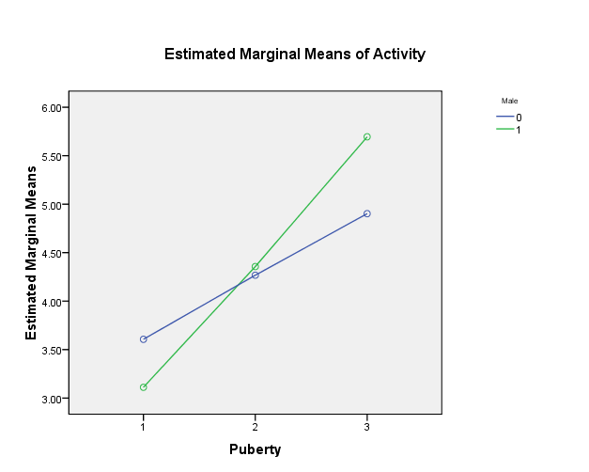 | 