Filename | cesd.sav
Overview | In Los Angeles (circa 1980), interviewers from the Institute for Social Science Research at UCLA surveyed a multiethnic sample of 256 community members for an epidemiological study of depression and help-seeking behavior among adults (Afifi and Clark 1984). The CESD depression index was used to measure depression. The index is constructed by asking people to respond to 20 items: "I felt I could not shake off the blues", "My sleep was restless", and so on. For each item, respondents answered "less than 1 time per week" (score 0); "1 to 2 days per week" (score 1); "3 to 4 days per week" (score 2), or "5 to 7 days" (score 3). Responses to the 20 items were summed to form a TOTAL score. Persons with a CESD TOTAL greater than or equal to 16 are classified as depressed (DEPRESSED=1).
Source | (From SYSTAT Data handbook.)
Sample size | 256 Angelinos

Theory 1: Depression is largely cognitive, so people with greater cognitive skills will be able to better master and avoid depression.
Research Question 1: In the population, educational attainment and depression are related such that more highly educated people will be less likely to be depressed.

Theory 2: Females have higher serotonin-kl levels, which make them more susceptible to depression.
Research Question 2: In the population, females are over-represented among the depressed.

Theory 3: Girls mature at an earlier age than boys, and this educational advantage persists into adulthood and throughout life.
Research Question 3: In the population, females attain higher levels of education than males.

Outcome Variable:
DEPRESSED | Depressed as defined by ≥16 on the CESD | Dichotomous
Predictor Variables:
MALE | 0 = Female  1 = Male | Dichotomous
EDUCATION | 2 = Drop Out  3 = HS Grad  4 = Some College  5 = 4-Year Degree | Polychotomous

Post Hole A—Interpret a contingency table with chi-square statistic.

Interpret the contingency table: (Use the APA style.)
The relationship between depression and educational attainment is statistically significant, χ²(3) = 8.075, p = .044.

The null hypothesis is that, in the population, there is no relationship between depression and educational attainment. Based on a p-value of less than .05, we reject the null hypothesis, and we conclude that there is a relationship in the population. High school dropouts are particularly likely to be depressed. (You may also want to say something about Angelinos with some college.)

Independence seems reasonable, but maybe clustering within neighborhoods.
All expected are 5 or greater.
*
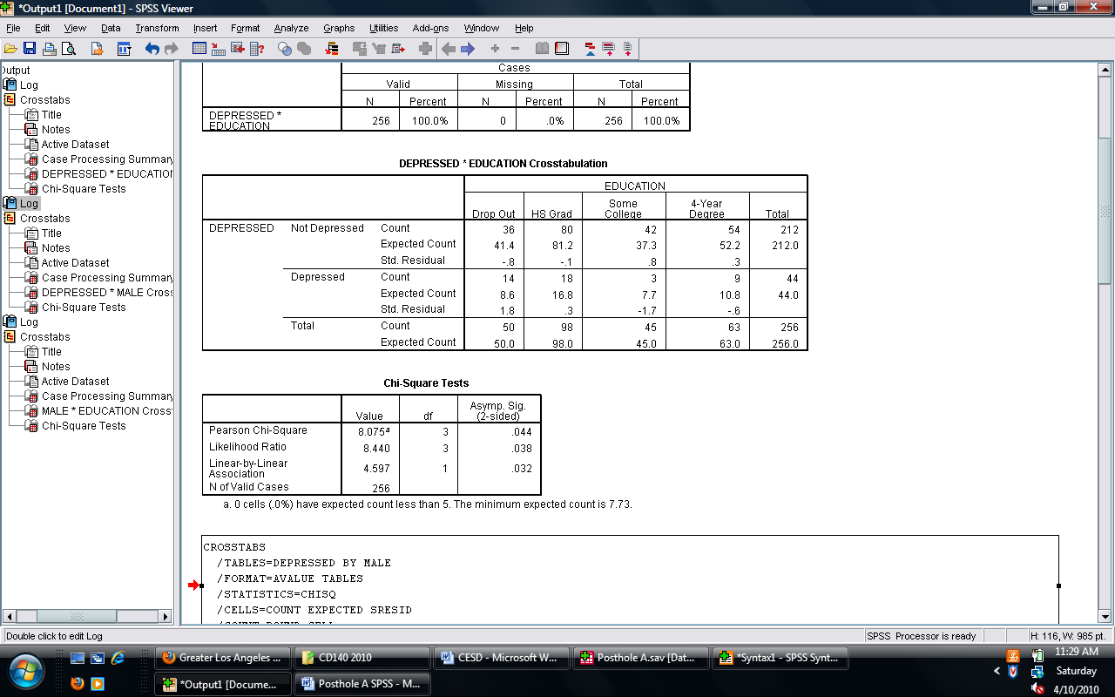

Post Hole A—Interpret a contingency table with chi-square statistic.

Interpret the contingency table: (Use the APA style.)
The relationship between depression and sex is statistically significant, χ²(1) = 11.095, p = .001.

The null hypothesis is that, in the population, there is no relationship between depression and sex. Based on a p-value of less than .05, we reject the null hypothesis, and we conclude that there is a relationship in the population. Male Angelinos are particularly unlikely to be depressed.

Independence seems reasonable, but maybe clustering within neighborhoods.
All expected are 5 or greater.
*
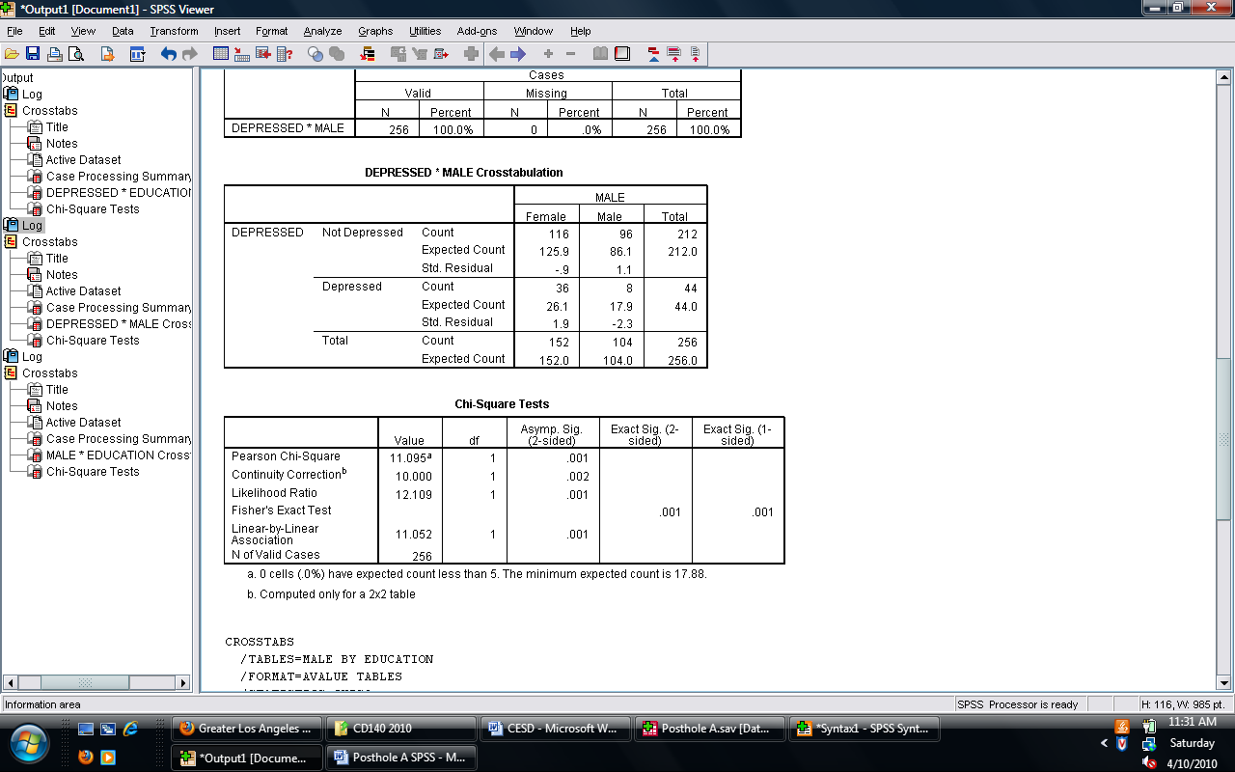

Post Hole A—Interpret a contingency table with chi-square statistic.

Interpret the contingency table: (Use the APA style.)
The relationship between depression and educational attainment is not statistically significant, χ²(3) = 1.900, p = .593.

The null hypothesis is that, in the population, there is no relationship between sex and educational attainment. Based on a p-value of greater than .05, we do not reject the null hypothesis, and we do not conclude that there is a relationship in the population.

Independence seems reasonable, but maybe clustering within neighborhoods.
All expected are 5 or greater.
*
